COCHIN UNIVERSITY OF SCIENCE AND TECHNOLOGY
COCHIN UNIVERSITY COLLEGE OF ENGINEERING
KUTTANADU


APRIL 2026
PROJECT REPORT ON
PREDICTCARE- SMART ANALYTICS FOR MODERN HEALTHCARE

Submitted on partial fulfillment of the requirement for the award of the degree in Master of
Computer Applications from COCHIN UNIVERSITY OF SCIENCE AND TECHNOLOGY

Submitted by
JESWIN SUNNY (24030467)

DIVISION OF COMPUTER APPLICATIONS
2024-2026
COCHIN UNIVERSITY OF SCIENCE AND TECHNOLOGY
COCHIN UNIVERSITY COLLEGE OF ENGINEERING
KUTTANADU



CERTIFICATE

This is to certify that this project report entitled “PREDICTCARE- SMART ANALYTICS FOR MODERN HEALTHCARE” is a Bonafide record on partial fulfilment for the Degree of the Master of Computer Applications to the COCHIN UNIVERSITY OF SCIENCE AND TECHNOLOGY through DIVISION OF COMPUTER APPLICATIONS, COCHIN UNIVERSITY COLLEGE OF ENGINEERING KUTTANADU, ALAPPUZHA done by JESWIN SUNNY (24030467) in the year 2026.

Project Guide Project Coordinator Head of the Department
Ms. DIVYA G Ms. DIVYA G Prof. (Dr) PREETHA MATHEW K
Asst. Professor MCA Asst. Professor MCA Principal
CUCEK CUCEK CUCEK

Examiner

DECLARATION
I hereby declare that the project entitled “PREDICTCARE- SMART ANALYTICS FOR MODERN HEALTHCARE” submitted to the DIVISION OF COMPUTER APPLICATIONS, COCHIN UNIVERSITY COLLEGE OF ENGINEERING, KUTTANADU in the partial fulfilment of the requirements for the award of Degree in MASTER OF COMPUTER APPLICATIONS is record of original work done by me under the guidance of Ms. DIVYA G, Assistant Professor in MCA Department during my period of studying at Cochin University College of Engineering, Kuttanadu.

Place: JESWIN SUNNY
Date:

ACKNOWLEDGEMENT

I am thankful to God almighty for the blessings in the successful completion of my main project “PREDICTCARE- SMART ANALYTICS FOR MODERN HEALTHCARE”. I would like to record my profound gratitude to Prof. (Dr) PREETHA MATHEW K, Principal and Head of the Department, MCA, Cochin University College of Engineering who has deeply inspired me to do my project. It’s grateful to express my thanks to Ms. DIVYA G, Assistant Professor in MCA Department my Project guide and coordinator, Cochin University College of Engineering, Kuttanadu, because of her effective guidance, constructive criticism and innovative and useful stream of suggestions that helped me to complete my project. I am thankful to various resources that provide requirements for my project, because requirements are backbone of every project. I am also thankful to my teachers, friends, family members, for their support and prayer for me to complete my project.

ABSTRACT

PredictCare is a comprehensive, production-ready Hospital Management and Analytics System designed to digitize and optimize healthcare operations. Developed using Django 5.x and a PostgreSQL database engine, the system serves as a unified ecosystem for patient registration, clinical visit tracking, and multi-departmental administration.
The core innovation of PredictCare lies in its integration of automated logic and Artificial Intelligence. It features the SMSR (Staff Management & Shift Rotation) algorithm, a modulo-based engine that ensures fair, conflict-free 24/7 staffing coverage across all clinical departments by automating the complex scheduling of doctors and nurses. Furthermore, the system leverages Machine Learning (Scikit-Learn) and Pandas to provide administrators with proactive insights, including predictive patient traffic forecasting, medicine stock depletion alerts, and staffing load diagnostics.
Complementing these features is a robust Pharmacy Management module that integrates clinical prescriptions directly with inventory tracking, enabling automated digital billing and real-time stock control. With a responsive frontend built on Tailwind CSS and interactive data visualizations powered by Chart.js, PredictCare transforms passive historical data into an actionable tool for superior hospital resource planning and enhanced patient care delivery.

CONTENTS
- INTRODUCTION 1
  - ABOUT THE PROJECT
  - OBJECTIVE AND SCOPE OF PROJECT
  - DEFINITION OF PROBLEM
- LITERATURE REVIEW 8
- SYSTEM ANALYSIS 11
  - EXISTING SYSTEM
    - DISADVANTAGES
  - PROPOSED SYSTEM
    - ADVANTAGES
    - MODULES
  - FEASIBILITY STUDY
- SYSTEM REQUIREMENTS AND SPECIFICATIONS 19
  - HARDWARE CONFIGURATIONS
  - SOFTWARE CONFIGURATIONS
  - TECHNOLOGY USED
  - PLATFORM USED
- SYSTEM DESIGN 24
  - DATABASE DESIGN
  - DATAFLOW DIAGRAM
5.2.1 DFD LEVEL 0
5.2.2 DFD LEVEL 1 ADMIN
5.2.3 DFD LEVEL 1 STUDENT
5.2.4 DFD LEVEL 1 WARDEN
5.3 CLASS DIAGRAM
5.4 SEQUENCE DIAGRAM
5.5 ER DIAGRAM
5.6 ACTIVITY DIAGRAM
5.7 USE CASE DIAGRAM
- SYSTEM IMPLEMENTATION, TESTING AND MAINTENANCE 37
- SAMPLE CODE 43
- SCREENSHOTS 80
- CONCLUSION 91
- REFERENCES 96

LIST OF FIGURES
5.2.1 DFD LEVEL 0 29
5.2.2 DFD LEVEL 1 ADMIN 29
5.2.3 DFD LEVEL 1 DOCTOR 30
5.2.4 DFD LEVEL 1 PHARMACY 30
5.2.5 DFD LEVEL1 RECEPTION 31
5.3 CLASS DIAGRAM 32
5.4 SEQUENCE DIAGRAM 33
5.5 ER DIAGRAM 34
5.6 ACTIVITY DIAGRAM 35
5.7 USECASE DIAGRAM 36

1.INTRODUCTION
1.1 ABOUT THE PROJECT
PredictCare is a sophisticated, AI-augmented Hospital Management and Analytics System designed to digitize and optimize healthcare operations for Hospital. Built using the Django 5.x framework and a robust PostgreSQL database, the platform serves as a unified digital ecosystem that replaces traditional manual record-keeping with automated, secure workflows. The project's primary mission is to transition hospital administration from a reactive state to a proactive, data-driven strategy, ensuring that both human and medicinal resources are managed with maximum efficiency.
At its core, PredictCare provides a comprehensive clinical management suite that handles the entire patient lifecycle, from unique ID registration and clinical visit logging to secure document management. A standout feature of the system is the integrated Pharmacy Module, which bridges the gap between doctor consultations and medication dispensing. By linking real-time inventory tracking with automated digital billing, the platform ensures accurate financial reconciliation while maintaining critical stock levels through automated threshold alerts.

1.2 OBJECTIVE & SCOPE OF THE PROJECT
OBJECTIVE
The primary objective of PredictCare is to implement a robust, AI-enhanced Hospital Management System that digitizes clinical workflows and optimizes resource allocation for hospitals. By replacing manual registries with a unified digital ecosystem, the project aims to eliminate administrative bottlenecks and ensure a seamless, secure flow of information across all hospital departments. This objective focuses on enhancing operational precision while empowering healthcare leadership with proactive, data-driven insights to elevate the quality of patient care.
Key Specific Objectives:
• To implement a centralized patient registry with unique digital identifiers for error-free patient tracking.
• To automate clinical visit logging, symptoms, and diagnoses to provide a complete, digital medical history.
• To deploy the SMSR (Staff Management & Shift Rotation) algorithm for autonomous, conflict-free 24/7 staff scheduling.
• To ensure 100% fair and consistent shift distribution for medical personnel, alleviating manual scheduling burdens.
• To synchronize doctor prescriptions directly with real-time inventory tracking for high-accuracy medicine management.
• To automate digital billing, ensuring instantaneous and transparent financial reconciliation for patients.
• To maintain critical medicine stock levels through automated threshold alerts and real-time ledger monitoring.
• To utilize Machine Learning (Scikit-Learn) to forecast patient traffic volumes per department up to 90 days in advance.
• To anticipate medicinal demand cycles using predictive data modeling to prevent stock shortages.
• To provide administrators with "overload" alerts and staffing diagnostics based on predictive doctor-to-patient ratios.
• To furnish leadership with interactive, data-driven dashboards for informed executive decision-making.
• To deliver a responsive, role-based web interface accessible across desktop and mobile devices for all user classes.

SCOPE
The functional scope of PredictCare encompasses the development and implementation of a centralized Hospital Management and Predictive Analytics System for Hospitals. At its core, the project is designed to handle the full lifecycle of clinical administration, ranging from patient registration and clinical visit logging to post-consultation management. By establishing a secure, role-based web interface, the system ensures that sensitive medical records and diagnostic histories are stored in a unified database, providing a single source of truth for receptionist staff, doctors, and hospital administrators.

Beyond administrative record-keeping, the scope extends heavily into operational automation through the deployment of the SMSR (Staff Management & Shift Rotation) scheduling engine. This module is responsible for the autonomous generation of conflict-free 24/7 staffing rotations for doctors and nurses across all hospital departments. By mathematically distributing morning, evening, and night shifts, the system ensures that specialized medical resources are optimally allocated and available to patients at any hour, thereby eliminating the complexities and errors associated with manual shift planning.
The project also includes a robust Pharmacy and Financial Management module designed to bridge the gap between clinical consultations and pharmaceutical dispensing. This scope includes the real-time monitoring of medicine stock levels, synchronized prescription integration, and automated digital billing functionalities. By issuing automated low-stock threshold alerts and maintaining a continuous ledger of all pharmaceutical transactions, PredictCare ensures that the hospital can maintain a reliable supply of vital medications while providing patients with immediate and transparent financial reconciliation for their treatment and pharmacy costs.
The strategic and technical scope of PredictCare is defined by its integration of advanced Machine Learning models to facilitate proactive resource planning. Utilizing Scikit-Learn and Pandas, the system is designed to forecast future patient traffic trends and anticipate medicinal demand cycles up to 90 days in advance. This predictive layer, coupled with interactive data visualization dashboards, empowers hospital leadership with the analytical tools needed for informed executive decision-making. Architecturally, the system is built on a responsive Django 5.x and PostgreSQL stack, ensuring it is accessible across desktop and mobile devices for a seamless user experience.

1.3 DEFINITION OF PROBLEM
Traditional hospital management environments often rely on fragmented, manual record-keeping systems that are prone to human error and operational inefficiencies. In these conventional settings, patient registration, clinical visit logs, and medical histories are frequently maintained in physical registries or isolated digital spreadsheets. This fragmentation creates significant information silos, making it difficult for healthcare providers to access real-time patient data and resulting in delayed decision-making, redundant data entry, and a higher risk of diagnostic inaccuracies.
A critical challenge in modern hospital administration is the complexity of managing 24/7 staff scheduling across multiple clinical departments. Manual scheduling for large teams of doctors and nurses is an arduous, error-prone task that often leads to scheduling conflicts, coverage gaps, and uneven work distribution. These inefficiencies can result in practitioner fatigue, decreased morale, and, most importantly, compromised patient care quality during periods of high demand or critical staffing shortages.
Furthermore, there is often a significant disconnect between clinical consultations and pharmaceutical inventory management. Without a unified system, pharmacy staff have no direct visibility into doctor-issued prescriptions, leading to manual verification processes that slow down patient discharge. This lack of integration often results in inventory inaccuracies, where vital medications may go out of stock without warning, or expired medications may be improperly tracked, creating both financial liabilities and health risks for patients.
Finally, most traditional hospital systems are inherently reactive, meaning that administrators can only respond to patient surges or resource shortages after they occur. Without predictive tools to forecast patient traffic and medicinal demand, hospital leadership cannot effectively allocate resources in advance of seasonal spikes or unexpected load increases. This reliance on reactive management leads to overcrowded departments, overextended staff, and a general inability to maintain a consistent standard of care during fluctuating healthcare demands.

2. LITERATURE REVIEW

P. Shukla, A. Jadhav, S. Mahure, D. Shete and P. M. Chawan, “Optimized Hospital Management System with Analytics: A Survey,” International Research Journal of Engineering and Technology (IRJET), 2024.
This paper presents a comprehensive survey on modernizing hospital management through data analytics and resource optimization. The authors propose a framework that uses historical patient visit data to identify bottlenecks in hospital throughput and clinical workflows. By analyzing personnel allocation, the study demonstrates that automated data-driven systems can significantly reduce patient wait times and improve the overall efficiency of clinical staff. However, while the survey highlights the benefits of operational analytics, it identifies a research gap in the real-time integration of automated shift rotation algorithms (like SMSR) that can dynamically respond to fluctuating hospital loads.

A. K. Roy, S. Gayen and P. Renuka Devi, “Multidisease Prediction and Causality Analysis with Hospital Management System,” Proceedings of the 3rd International Conference on Applied Artificial Intelligence and Computing (ICAAIC), 2024.
Several recent studies, including this research presented at ICAAIC, emphasize the integration of predictive diagnostic capabilities directly into Hospital Management Systems (HMS). This paper describes a model that logs clinical symptoms and uses diagnostic sensors to perform multidisease prediction and causality analysis at the point of patient registration. The implementation demonstrates that embedding intelligence into the administrative workflow allows for more proactive patient care and better clinical coordination between departments. Although highly effective in diagnostic tracking, the authors note that the model requires high computational power for real-time causality analysis, highlighting a challenge for deployment in resource-constrained hospital settings.
K. Sharma and R. Kumar, “Smart Web-based Hospital Management System with Machine Learning Integration,” Journal of Healthcare Informatics and Management, 2023.
Sharma and Kumar’s research focuses on the transition from legacy offline software to responsive, web-based HMS architectures that incorporate Machine Learning (ML) for administrative support. The study details an effective framework that leverages role-based access control (RBAC) and ML-driven patient load forecasting to streamline the interaction between doctors, pharmacists, and administrative staff. The model demonstrates that a unified web-platform significantly improves data synchronization and reduces the manual burden of pharmacy billing and inventory tracking. However, most implementations reviewed primarily focus on individual department optimization and lack a comprehensive behavioral analytics layer to monitor long-term staffing diagnostics and organizational health.

3.SYSTEM ANALYSIS

3.1 EXISTING SYSTEM
The existing system in a typical healthcare facility like Hospital largely relies on manual, paper-based registries or fragmented digital documentation such as isolated spreadsheets and basic desktop databases. In this environment, patient registration, doctor consultations, and pharmacy records are often maintained as disconnected entities, requiring manual data reentry and physical movement of files between departments.

Limitations of the Existing System
• Fragmented Data Management
Patient medical histories and clinical visit logs are stored in physical files, making real-time retrieval difficult and increasing the risk of data loss.
• Manual Staff Scheduling
The complex task of managing 24/7 shift rotations for a large medical team is performed manually, leading to human errors, scheduling conflicts, and gaps in hospital coverage.
• Inventory Disconnect
The pharmacy operates independently of clinical consultations, requiring pharmacists to manually verify prescriptions before issuing bills and updating stock levels.
• Reactive Administrative Approach
Without analytical tools, hospital leadership can only react to patient surges or resource shortages after they occur, leading to department overcrowding and overextended staff.

• Lack of Reporting
Generating comprehensive operational reports (e.g., patient throughput or medicine consumption) is a time-consuming manual process that offers little to no predictive insight.

3.2 PROPOSED SYSTEM (PREDICTCARE)
The proposed system, PredictCare, is a unified, web-based Hospital Management and Predictive Analytics platform built to bridge the operational gaps of traditional healthcare administration. Developed using the Django 5.x framework and a PostgreSQL database, PredictCare integrates core hospital workflows with Artificial Intelligence to provide a proactive management environment. The system ensures that patient registration, scheduling, pharmacy, and analytics are connected through a secure, role-based interface.

Key Features & Advantages
• Centralized Electronic Health Records (EHR)
A unified registry that allows for the instantaneous retrieval of patient histories and visit logs, ensuring a seamless flow of information from reception to consultation.
• Automated SMSR Scheduling
The implementation of the Staff Management & Shift Rotation algorithm provides conflict-free 24/7 coverage, eliminating human error in shift planning and ensuring physician availability.

• Integrated Pharmacy & Digital Billing
Doctor-issued prescriptions are automatically synchronized with the pharmacy module, enabling real-time inventory updates and instantaneous digital billing for patients.
• Predictive AI Analytics
Utilizing Scikit-Learn and Pandas, the system forecasts future patient loads and medicinal demand up to 90 days in advance, allowing administrators to allocate resources proactively.
• Interactive Visualization Dashboards
Dynamic charts (powered by Chart.js) provide a real-time overview of hospital throughput, stock levels, and staffing ratios, supporting faster and more accurate executive decision-making.
• Secure Role-Based Access
Dedicated portals for Administrators, Doctors, Pharmacists, and Receptionists ensure that sensitive clinical data is only accessible to authorized personnel, maintaining strict patient confidentiality.
3.2.1 ADVANTAGES
• Automated Staff Management
The SMSR algorithm ensures 100% conflict-free 24/7 staffing, eliminating the human error and fatigue associated with manual shift planning.
• Proactive Resource Planning
Integrated Machine Learning (Scikit-Learn) allows administrators to forecast patient surges and medicine demand up to 90 days in advance.

• Real-Time Inventory Control
The pharmacy module provides instantaneous stock level updates and issues automated low-stock alerts, preventing critical medicine shortages.
• Seamless Data Integration
Clinical visit logs, doctor prescriptions, and pharmacy billing are fully synchronized, ensuring a unified flow of patient data across departments.
• Elimination of Paperwork
By digitizing patient registration and medical histories, the system significantly reduces physical archiving space and manual record-retrieval time.
• Enhanced Financial Accuracy
Automated digital billing reduces human computational errors and ensures transparent financial reconciliation for all clinical and pharmacy services.
• Secured Data Privacy
Robust Role-Based Access Control (RBAC) ensures that sensitive patient clinical data is only accessible to authorized personnel (e.g., doctors and admins).
• High Accessibility
The web-based architecture (Django/PostgreSQL) allows the platform to be accessed from any desktop or mobile device within the hospital network.

• Data-Driven Decision Making
Interactive Chart.js dashboards provide leadership with a real-time visual overview of hospital throughput, stock levels, and departmental ratios.
• Improved Patient Experience
Faster registration, automated scheduling, and instantaneous billing significantly reduce patient wait times and improve overall quality of care.

3.2.2 MODULES
• Hospital Core Module
• Pharmacy & Digital Billing Module
• Authentication & Security Module
• Analytical & AI Module
• Intelligent Scheduling Module
• Web-Based Configuration Module

3.3 FEASIBILITY STUDY
A feasibility study was conducted to determine the viability of the PredictCare system and to ensure that it would successfully meet the operational requirements of Hospital within technical and economic constraints.

1. TECHNICAL FEASIBILITY
The technical feasibility of PredictCare is high, as it leverages the proven and scalable Django 5.x framework and the PostgreSQL relational database engine. These technologies are well-suited for handling high-concurrency patient records and secure clinical data. The integration of Scikit-Learn and Pandas for predictive analytics is also technically viable, as these libraries provide robust, industry-standard support for the linear regression models used in patient load forecasting. The web-based architecture ensures that the system is accessible across existing hospital hardware without requiring significant infrastructure upgrades.

2. OPERATIONAL FEASIBILITY
Operationally, PredictCare is designed to align with existing hospital workflows while reducing the manual burden on staff. By providing dedicated, simple interfaces for receptionists, doctors, and pharmacists, the system ensures a high level of user acceptance. The automation of complex tasks, such as shift scheduling (SMSR Algorithm) and pharmacy billing, provides immediate, tangible benefits to daily operations. The system's role-based access control (RBAC) also ensures that administrative and clinical duty separations are maintained, making it operationally sound within a healthcare environment.

3. ECONOMIC FEASIBILITY
The economic feasibility of PredictCare is justified by a significant reduction in operational overhead and errors. By automating manual registries and scheduling, the hospital can reallocate human resources to direct patient care, thereby increasing throughput and revenue. Additionally, the proactive forecasting of medicine demand reduces financial losses associated with overstocking or stockouts of critical medications. The use of open-source technologies (Python, Django, PostgreSQL) further ensures that the project remains cost-effective by eliminating high licensing fees for proprietary software.

4. BEHAVIORAL & LEGAL FEASIBILITY
The system is behaviorally feasible as it provides intuitive, role-specific dashboards that require minimal specialized training for existing staff. Legally, the system implements robust record-keeping and data-encryption standards that align with patient privacy and healthcare data security regulations. By maintaining detailed audit logs of all clinical visits and financial transactions, PredictCare provides a transparent and legally compliant documentation trail for both administrative and diagnostic purposes

4. SYSTEM REQUIREMENTS
AND
SPECIFICATIONS

4.1 HARDWARE CONFIGURATIONS
The selection of hardware is very important in the existence and proper working of any of the
software. When selecting hardware, the size and capacity requirements are also important. This
software is able to run with following hardware configuration.

Processor : Intel core i3
Processor Speed : 1.5GHz to 2.2GHz
RAM : 4GB or above
Hard Disk : 3GB and above
Keyboard : 108 keys
Clock speed : 500 MHz
System bus : 32 bits

4.2 SOFTWARE CONFIGURATIONS
One of the most difficult tasks is selecting software, once the system requirement is found out, then, I have to determine whether a particular software package fits for those system requirements. This section summarizes the application requirement.
Operating System: Windows 8 or higher or MacOS
Language: Python, Html, CSS, JavaScript
Libraries: Scikit-Learn, Pandas, NumPY & ScyPY, Openpyxl, Joblib, Python-Dateutil
IDE: VS Code, Antigravity
Database: PostgreSQL

4.3 TECHNOLOGY USED
The PredictCare system is built on a modern, high-performance technology stack designed to handle the rigorous demands of healthcare administration and predictive analytics. By combining a production-ready backend framework with a scalable relational database and advanced data science modules, the system ensures both operational reliability and analytical precision. The technology selection prioritizes security, cross-platform accessibility, and the ability to process large-scale clinical datasets in real-time.
Core Technology Stack:
• Backend Framework
Python 3.10+ and the Django 5.x web framework, providing a secure and scalable server-side environment.
• Database Engine
PostgreSQL, an advanced open-source relational database used for high-integrity storage of patient and clinical records.
• Frontend Environment
HTML5, CSS3, and Tailwind CSS for creating a responsive, modern, and mobile-friendly user interface.

• Client-Side Scripting
Vanilla JavaScript used for dynamic UI interactions and providing real-time data updates.
• Data Science & AI
Scikit-Learn for implementing machine learning models and Pandas for high-speed data manipulation and analysis.
• Data Visualization
Chart.js for rendering interactive, browser-based graphical dashboards and analytical reports.
• Server & Deployment
WSGI/ASGI servers (like Gunicorn/Daphne) for deploying the monolithic Django application on Linux or Windows environments.
• Reporting Tools
OpenPyXL for generating professional, downloadable Excel-based clinical and administrative reports.

4.4 PLATFORM USED
PredictCare is designed as a web-based hospital management and analytics platform, ensuring cross-platform accessibility, centralized control, and seamless integration of real-time clinical monitoring and predictive technologies across different hospital environments.

Web Platform (Client-Side)
The application is platform-independent on the client side and is accessed through any standard modern web browser. This enables compatibility across multiple operating systems, including Windows, macOS, and Linux. The frontend is built using HTML5, CSS3, Tailwind CSS, and JavaScript, allowing healthcare professionals to interact with clinical dashboards, patient records, and analytical reports without requiring any additional proprietary software installation on hospital workstations or mobile devices.
Server-Side Platform
The backend operates on a Python-based server environment, utilizing the Django 5.x framework to handle complex application logic, user authentication, role-based access control (RBAC), and real-time clinical tracking. It integrates advanced data science and monitoring technologies (Scikit-Learn, Pandas, and the SMSR Scheduling Algorithm) to perform continuous analysis of hospital traffic, staffing ratios, and medicine demand cycles. The server manages all communication between the frontend and the PostgreSQL database, ensuring the efficient storage and retrieval of patient demographics, clinical visit logs, and predictive analytics data.
Storage Platform
The system utilizes a dual-layered storage architecture to ensure data integrity and security. A PostgreSQL relational database is used as the primary storage engine for all structured data, including patient identities, clinical consultations, and financial transactions. Additionally, the system employs local file storage within the server’s media directory to manage uploaded clinical documents, laboratory reports, and diagnostic scans, ensuring that comprehensive medical assets are securely archived and easily retrievable by authorized medical personnel.

5. SYSTEM DESIGN

5.1 DATABASE DESIGN
The database for PredictCare is designed using the PostgreSQL relational engine, emphasizing data integrity, normalization, and efficient retrieval of clinical records. The schema is organized into three primary clusters: Staff Management, Clinical Operations, and Pharmacy/Billing. Each entity is uniquely identified by a Primary Key (PK), while relational integrity is maintained through a robust network of Foreign Keys (FK) that synchronize patient visits with doctor consultations and pharmaceutical transactions.
Database Schema
DEPARTMENT
Fieldname | Type | Size | Constraint | Description
dept_id | integer | 50 | Primary Key | Department id
name | string | 150 | Not Null | Department

DOCTOR
Fieldname | Type | Size | Constraint | Description
staff_id | string | 50 | Primary Key | Staff Id
name | string | 150 | Not Null | Doctor Name
gender | string | 50 | Not Null | Gender Type
qualification | string | 500 | Not Null | Qualification
email | string | 100 | Not Null | Email Id
phone | integer | 10 | Not Null | Phone
specialization | string | 100 | Not Null | Specialization
shift_type | string | 50 | Not Null | Shift Type
dept_id | integer | 50 | Foreign Key | Department Id

NURSE
Fieldname | Type | Size | Constraint | Description
staff_id | string | 50 | Primary Key | Staff Id
name | string | 150 | Not Null | Doctor Name
gender | string | 50 | Not Null | Gender Type
qualification | string | 500 | Not Null | Qualification
email | string | 100 | Not Null | Email Id
phone | integer | 10 | Not Null | Phone
shift_type | string | 50 | Not Null | Shift Type
dept_id | integer | 50 | Foreign Key | Department Id

PATIENT
Fieldname | Type | Size | Constraint | Description
patient_id | string | 50 | Primary Key | Patient Id
patient_name | string | 150 | Not Null | Patient Name
age | integer | 3 | Not Null | Patient Age
date_of_birth | date | 8 | Not Null | Date Of Birth
gender | string | 50 | Not Null | Gender Type
doctor_id | string | 50 | Foreign Key | Doctor Id

PATIENT DOCUMENT
Fieldname | Type | Size | Constraint | Description
doc_id | integer | 50 | Primary Key | Document Id
doc_name | string | 100 | Not Null | Document Name
notes | string | 500 | Not Null | Notes on Patient
patient_id | string | 50 | Foreign Key | Patient Id

VISIT
Fieldname | Type | Size | Constraint | Description
visit_id | integer | 50 | Primary Key | Visit Id
case_type | string | 100 | Not Null | Case Type
visit_date | date | 8 | Not Null | Date Of Visit
medicines | string | 1000 | Not Null | Medicines
symptoms | string | 1000 | Not Null | Symptoms
patient_id | string | 50 | Foreign Key | Patient Id
dept_id | string | 50 | Foreign Key | Department Id
doc_id | string | 50 | Foreign Key | Doctor Id

PRESCRIPTION
Fieldname | Type | Size | Constraint | Description
prescription_id | integer | 50 | Primary Key | Prescription Id
qty | integer | 500 | Not Null | Quantity
dosage | string | 100 | Not Null | Dosage
visit_id | integer | 50 | Foreign Key | Visit Id
med_id | integer | 50 | Foreign Key | Medicine Id

PHARMACY BILL
Fieldname | Type | Size | Constraint | Description
bill_id | integer | 100 | Primary Key | Bill Id
cus_name | string | 100 | Not Null | Customer Name
amt | float | 100 | Not Null | Total Amount
patient_id | string | 50 | Foreign Key | Patient Id

BILL ITEM
Fieldname | Type | Size | Constraint | Description
bill_id | integer | 100 | Foreign Key | Bill Id
qty | integer | 100 | Not Null | Quantity
ppu | float | 100 | Not Null | Price Per Unit
amt | float | 100 | Foreign Key | Total Amount
med_id | integer | 50 | Foreign Key | Medicine Id

MEDICINE
Fieldname | Type | Size | Constraint | Description
med_id | integer | 50 | Primary Key | Medicine Id
med_name | string | 100 | Not Null | Medicine Name
price | float | 100 | Not Null | Medicine Price
stock_qty | integer | 1000 | Not Null | Stock Quantity
min_stock | integer | 1000 | Not Null | Minimum Stock
exp_date | date | 8 | Not Null | Expiry Date

5.2 DATA FLOW DIAGRAM
5.2.1 DFD Level-0
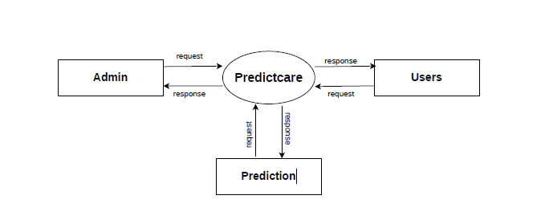5.2.2 DFD Level 1.0------- Admin
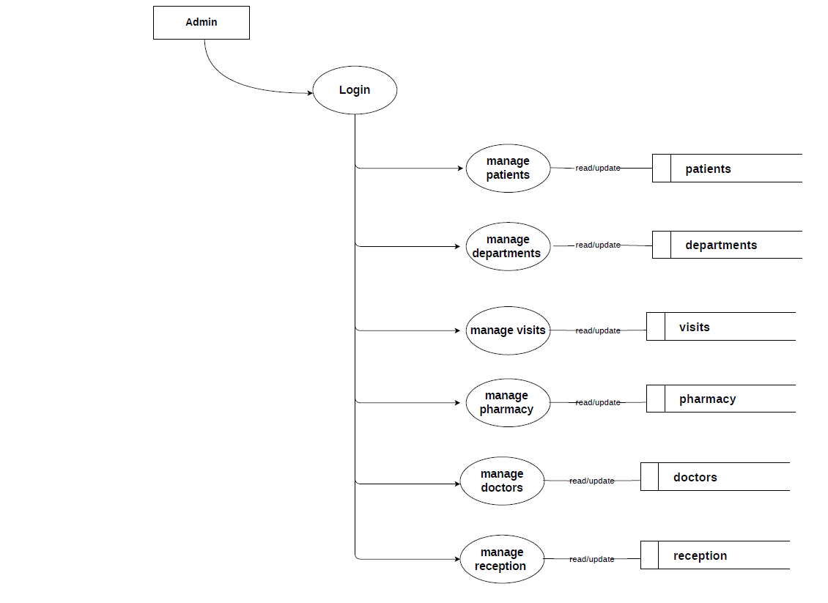
5.2.3 DFD Level-1-------Doctor
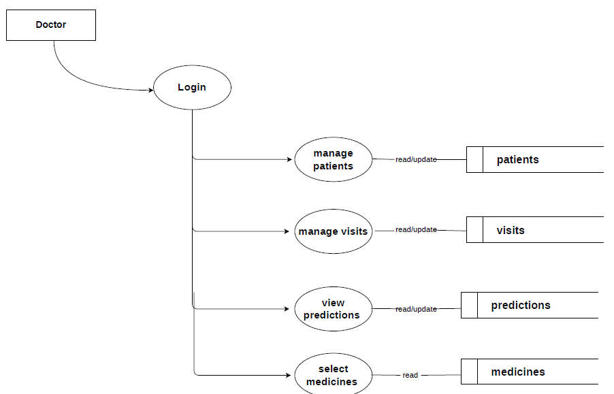

5.2.4 DFD Level-1-------Pharmacy
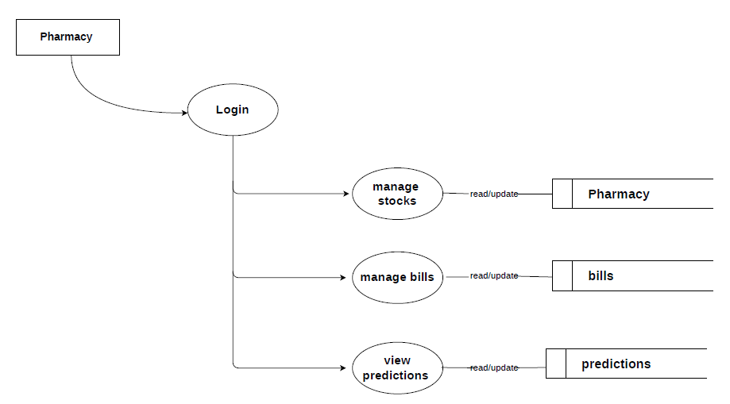
5.2.5 Level-1-------Reception
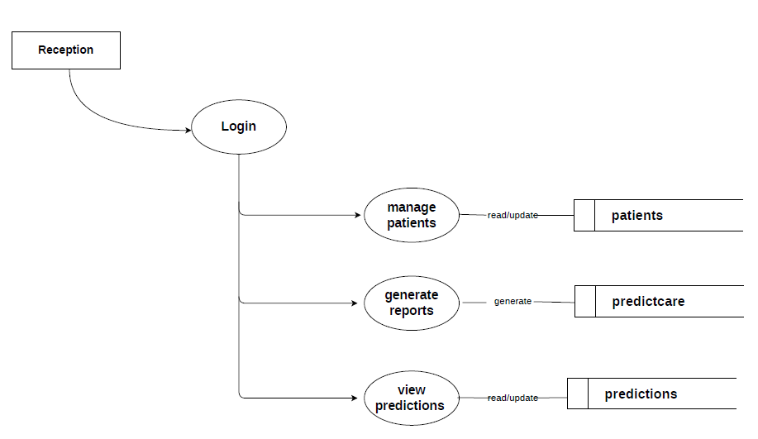

5.3 CLASS DIAGRAM
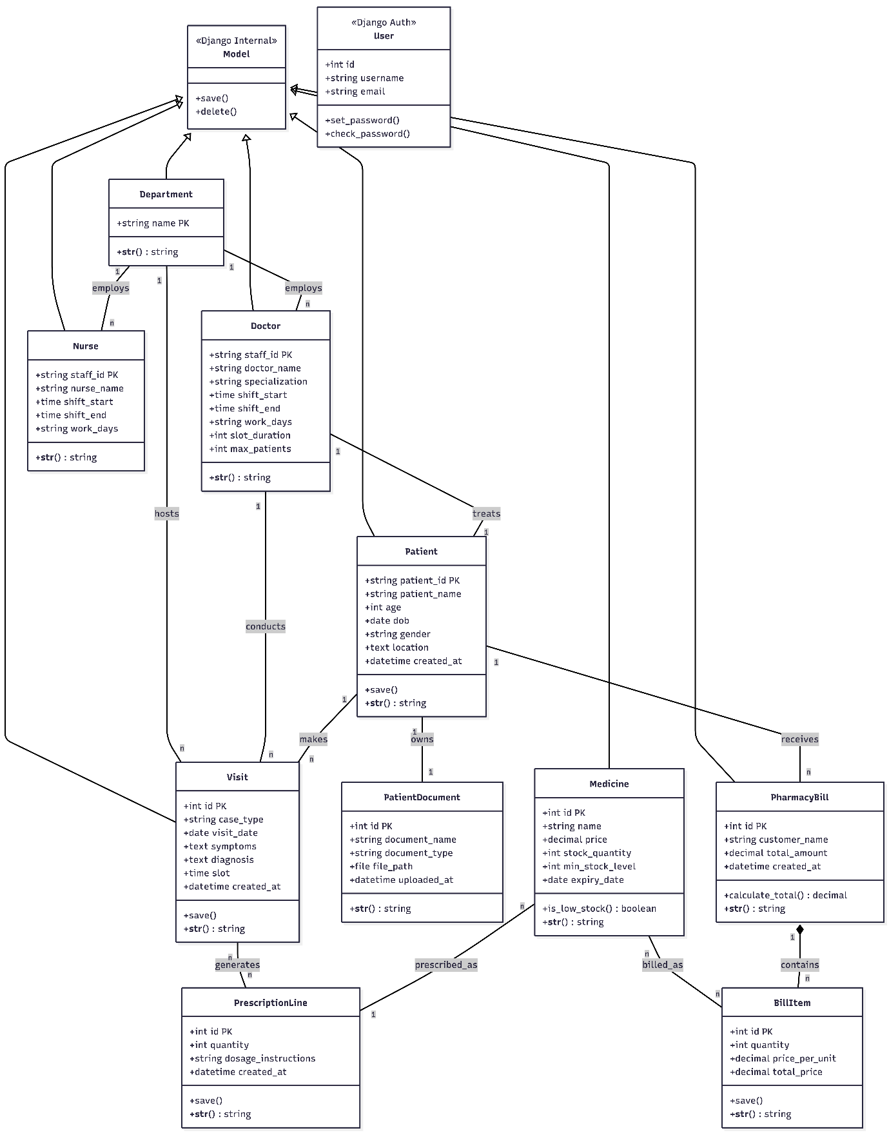

5.4 SEQUENCE DIAGRAM
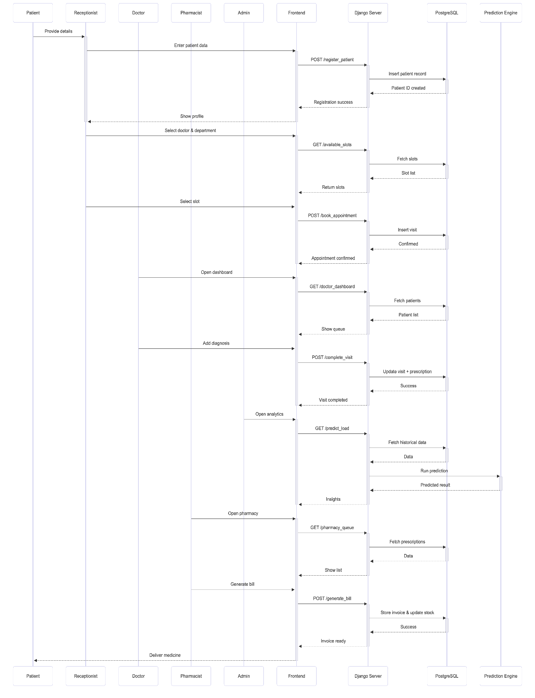

5.5 ER DIAGRAM
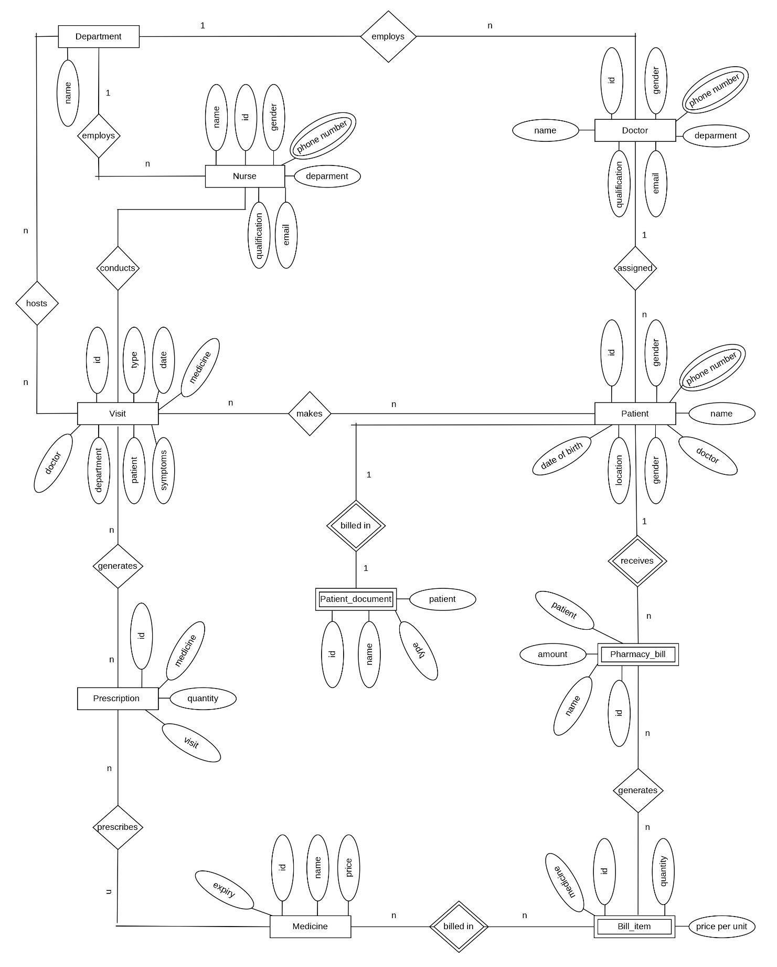

5.6 ACTIVITY DIAGRAM
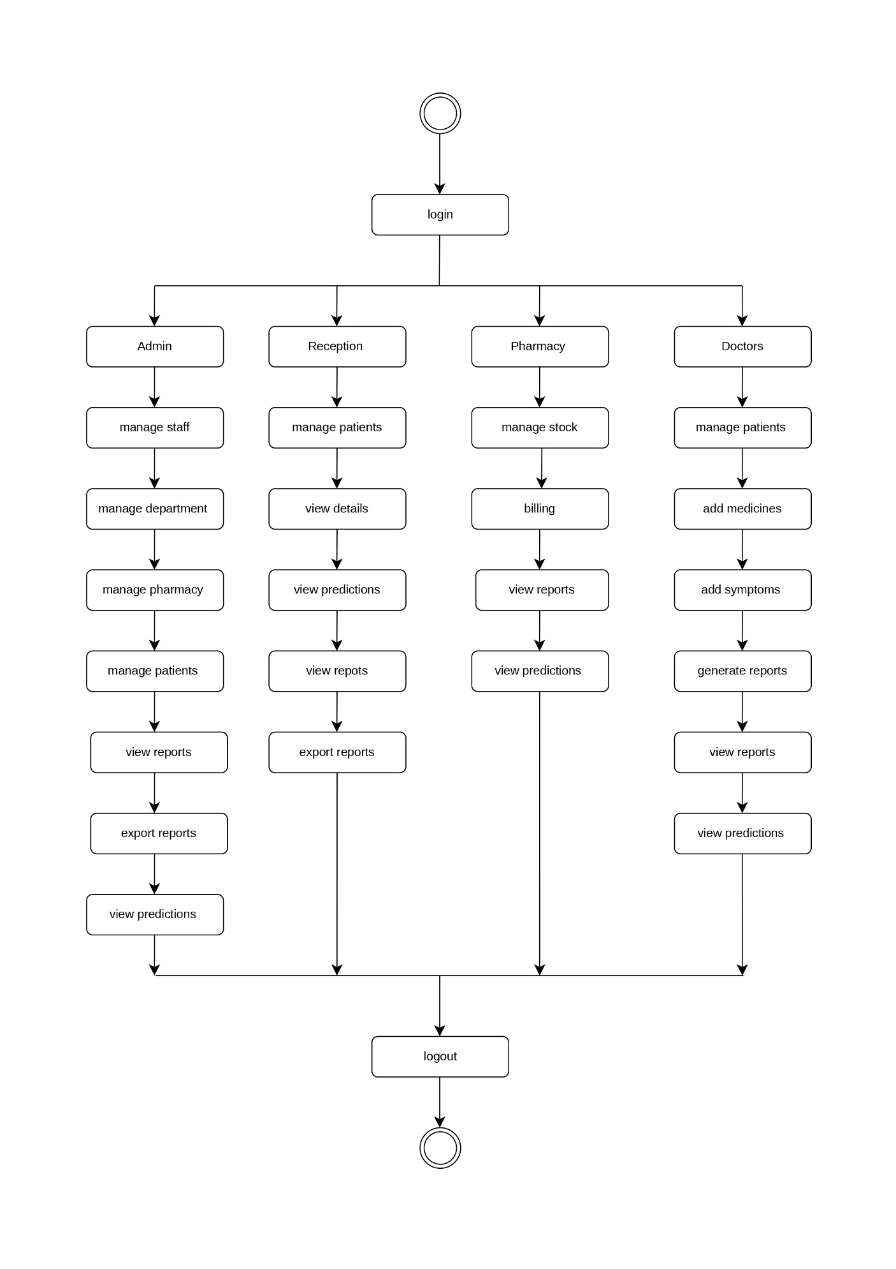
5.7 USE CASE DIAGRAM
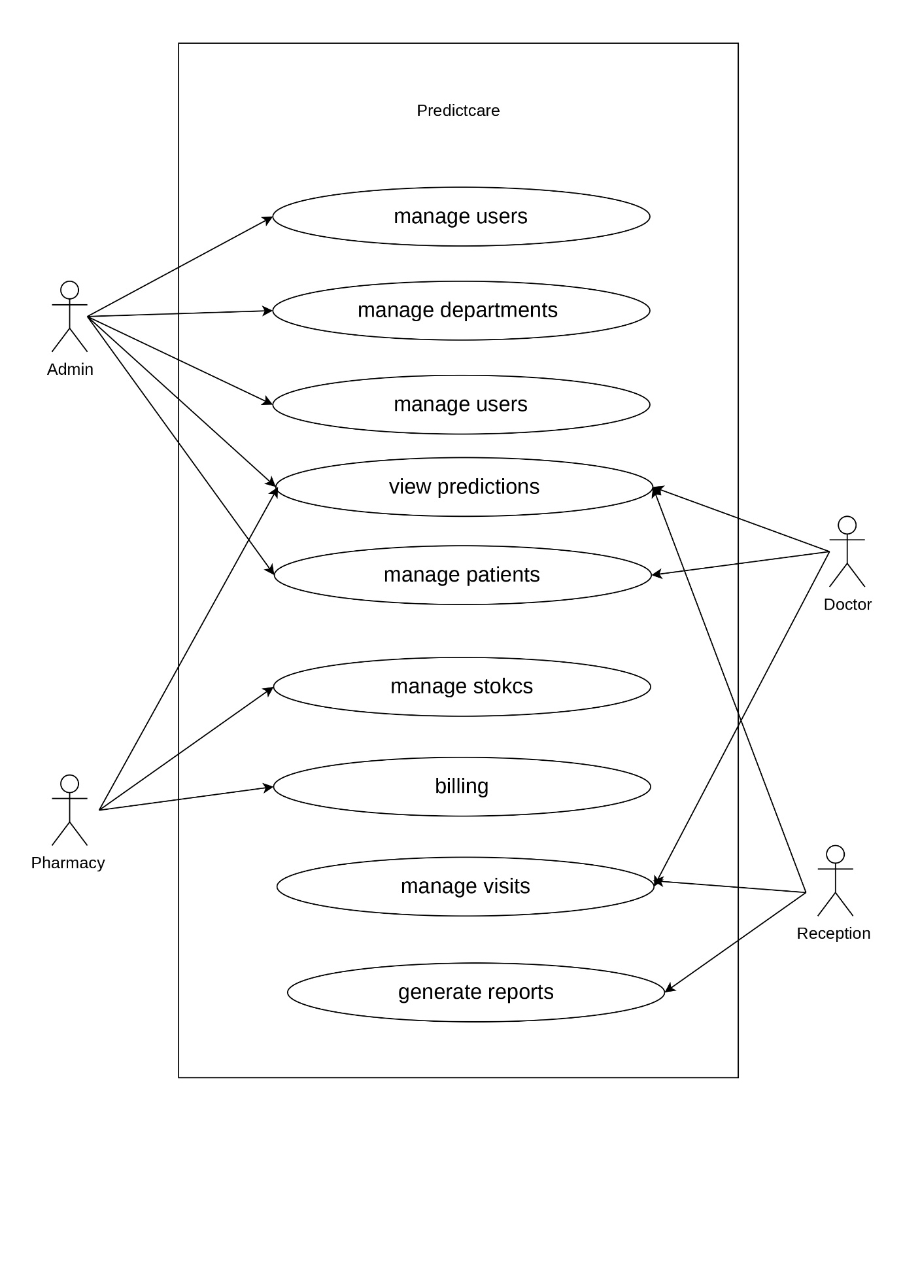

6. SYSTEM IMPLEMENTATION,
TESTING
&
MAINTENANCE

6.1 SYSTEM IMPLEMENTATION
The system is implemented using the Django framework, a robust and scalable Python-based web framework that supports rapid development and clean architecture. Django handles core functionalities such as user authentication, role-based access control, and complex database interactions across hospital departments. Predictive analytics engine features are integrated using machine learning libraries like Scikit-Learn and Pandas, along with Ordinary Least Squares (OLS) regression models and automated staff rotation algorithms to enable data-driven resource forecasting and efficient hospital management.
6.2 SYSTEM TESTING
System testing is conducted to validate the complete and integrated PredictCare platform, ensuring that all modules function correctly together in a real-time hospital management environment. The objective is to verify end-to-end system performance, including user interaction, prediction accuracy, and large-scale data handling.
Two Category of Software Testing
- Black Box Testing
- White Box Testing
System testing falls under the black box testing category, where the system is evaluated from the user’s perspective without examining internal code structure.
System Testing involves verifying the following:
- Testing the fully integrated system, including the seamless synchronization between the Pharmacy billing module, Doctor consultation portal, and Reception dashboard.
- Validating all inputs such as patient registration data, diagnostic logs, and medicine prescriptions to ensure correct invoice generation and stock updates.
- Testing real-time analytics features, including department-wise load forecasting, medicine demand prediction, and trend visualization for accuracy and reliability.
- Evaluating the user experience for Patients, Doctors, Pharmacists, and Administrators to ensure smooth operation, intuitive navigation, and system usability.
- Verifying proper recording, storage, and retrieval of timestamped clinical histories, pharmacy transactions, and automated staff shift logs.
Comprehensive test cases are designed to ensure the system performs reliably under real-time conditions without exposing internal implementation details.
6.2.1 UNIT TESTING
Unit testing is performed on individual modules of the PredictCare system during development to ensure that each component functions correctly in isolation. Developers test modules such as user authentication, pharmacy inventory deduction, predictive load analytics, patient records management, and automated shift rotation using sample inputs and verifying expected outputs. The primary objective is to identify and fix defects at an early stage by isolating each functional unit.
ADVANTAGES:
- Reduces defects in newly developed features and minimizes bugs during updates.
- Lowers overall testing cost by identifying logical issues early in development.
- Improves code quality, structure, and maintainability across the hospital apps.
- Ensures reliability of individual modules before they are integrated into the main system.

TECHNIQUES
- Black Box Testing - Used to test the user interface, input fields, and output results from the hospital dashboards.
- White Box Testing - Used to test the internal logic of functions like the SMSR rotation algorithm and ML regression behavior.
- Grey Box Testing - Used to execute tests, evaluate database risks, and assess the integration between hospital and pharmacy modules.

6.2.2 INTEGRATION TESTING
The meaning of Integration testing is quite straightforward—Integrate/combine the unit-tested modules one by one and test the behavior as a combined unit. The main function or goal of this testing is to test the interfaces between the units/modules. Here, testing is carried out by combining individual modules of the PredictCare system and testing their interaction as a unified system. Modules such as user authentication, patient scheduling, predictive analytics (ML), and pharmacy database operations are integrated progressively to verify seamless communication and correct data flow. In hospital systems, most of the time all the modules (like emergency-specific logs) are not actually available at once, and here is where the challenge comes to test the synchronization between clinical data and billing portals!
ADVANTAGES
There are several advantages of this testing and a few of them are listed below:
- Ensures that integrated modules such as pharmacy inventory and billing work cohesively.
- Detects interface-related errors between modules like the doctor’s portal and the diagnostic reporting system.
- Allows early testing using stubs and drivers even if all departments of the hospital system are not yet fully developed.
6.2.3 SYSTEM TESTING
System Testing (ST) is a black box testing technique performed to evaluate the complete system's compliance against specified requirements. In System testing, the functionalities of the system are tested from an end-to-end perspective. System testing is conducted to evaluate the complete PredictCare system as a fully integrated platform, ensuring it meets all specified hospital operational requirements. It is a black-box testing approach where the system is tested from the user's perspective (Doctors, Receptionists, and Pharmacists) without considering internal implementation details.
The testing includes end-to-end validation of functionalities such as patient registration, appointment scheduling, diagnostic logging, prescription generation, and automated pharmacy billing. Both functional and non-functional aspects like database performance (handling 1,000,000+ records), reliability, and usability (via interactive Chart.js analytics) are evaluated.
Test cases are designed based on system requirements to verify that for given clinical inputs, the system produces correct medical and financial outputs. This ensures that the platform operates reliably in real-time hospital scenarios while maintaining data accuracy, security, and a seamless user experience for both staff and patients.
6.2.4 TEST REPORT
The Test Report documents the outcomes of testing activities conducted on the PredictCare system in a structured and formal manner. It provides a clear summary of test cases executed, results obtained, and the overall system performance against predefined requirements for a production-ready hospital environment. The report includes details such as test environment conditions (Django/PostgreSQL configuration), input scenarios, detected issues, and their resolution status. It also compares expected and actual outputs to evaluate system accuracy, especially in modules like predictive load analytics, automated pharmacy billing, and RBAC security validation. This enables quick assessment of system reliability, performance under high-volume data (1M+ visit records), and readiness for clinical deployment.
6.3 SYSTEM MAINTENANCE
System maintenance is a critical phase of PredictCare, ensuring long-term reliability, performance, and adaptability of the platform in a clinical environment. A structured maintenance plan is established to handle user feedback from hospital staff, bug reporting for billing and analytics, and system enhancements after deployment. It defines procedures for requesting modifications to medical reporting logic, resolving data synchronization issues, and updating pharmacy inventory features.
The maintenance process includes regular updates to improve prediction accuracy in the ML engine, optimize database performance for high-volume visit logs, and ensure compatibility with evolving web technologies. Resource allocation and cost estimation are considered to support ongoing hospital operations.
Given that the system involves continuous data processing and evolving AI-based components for load forecasting, periodic upgrades and model refinements are essential. Proper adherence to healthcare data standards and consistent monitoring of system performance ensure that the platform remains secure, efficient, and aligned with hospital and institutional requirements over time.

7. SAMPLE CODE

views.py
import json
import logging
from collections import Counter
from datetime import datetime, date, timedelta
import pandas as pd
import openpyxl
from openpyxl.utils import get_column_letter
from django.shortcuts import render, redirect, get_object_or_404
from django.http import JsonResponse, HttpResponse
from django.views.decorators.csrf import csrf_exempt
from django.contrib.auth.decorators import login_required
from django.db.models import Count, Q
from django.core.exceptions import ObjectDoesNotExist
from django.db import transaction
from django.core.cache import cache

from .models import Department, Doctor, Nurse, Patient, Visit
from ml.predict_load import (
predict_department_load_from_df,
predict_department_load_over_time_from_df,
analyze_staffing_from_df,
predict_medicine_demand_from_df,
analyze_peak_traffic_from_df
)

logger = logging.getLogger(__name__)

# ----------------------------------------------------------------------
# Helpers
# ----------------------------------------------------------------------

def calculate_age(dob_obj):
"""Calculate age from date object."""
if not dob_obj:
return ""
if isinstance(dob_obj, str):
try:
dob_obj = datetime.strptime(dob_obj, "%Y-%m-%d").date()
except:
return ""

today = date.today()
age = today.year - dob_obj.year - ((today.month, today.day) < (dob_obj.month, dob_obj.day))
return age

# ----------------------------------------------------------------------
# Auth Views (Handled by accounts app now)
# ----------------------------------------------------------------------

# ----------------------------------------------------------------------
# Hub & Staff Views
# ----------------------------------------------------------------------
@login_required
def hub_view(request):
"""
Dispatcher view: Redirects users to their specific dashboard based on role.
"""
user = request.user
if user.is_superuser:
return redirect('admin_dashboard')

# Check Groups
if user.groups.filter(name='Receptionist').exists() or user.username == 'receptionist':
return redirect('reception_dashboard')
elif user.groups.filter(name='Doctor').exists():
return redirect('doctor_dashboard')
elif user.groups.filter(name='Pharmacy').exists() or user.username == 'pharmacy':
return redirect('pharmacy_inventory')

# Check Models directly (fallback for doctors not in Group)
if Doctor.objects.filter(staff_id=user.username).exists():
return redirect('doctor_dashboard')
elif Nurse.objects.filter(staff_id=user.username).exists():
# Nurses might share Reception dashboard or have their own view? defaulting to Reception for now or Hub
return redirect('reception_dashboard')

# Fallback for generic staff
return render(request, "hub.html")

@login_required
def admin_dashboard(request):
return render(request, "dashboards/admin.html")

@login_required
def reception_dashboard(request):
# Similar context to original index.html but for reception
context = {
"doctors_by_dept": get_doc_map(),
"departments": list(Department.objects.values_list('name', flat=True).order_by('name')),
"is_reception": True
}
return render(request, "dashboards/reception.html", context)

@login_required
def doctor_dashboard(request):
# Filter visits for this doctor if possible
# We try to match the logged-in user's username to the Doctor's staff_id
try:
doctor = Doctor.objects.get(staff_id=request.user.username)
my_visits = Visit.objects.filter(doctor=doctor).select_related('patient').order_by('-visit_date')
except Doctor.DoesNotExist:
# If user is in Doctor group but not in Doctor table (e.g. mismatch), show empty
my_visits = []
doctor = None

context = {
"my_visits": my_visits,
"doctor": doctor
}
return render(request, "dashboards/doctor.html", context)

@login_required
def doctor_analytics(request):
try:
doctor = Doctor.objects.get(staff_id=request.user.username)
except Doctor.DoesNotExist:
return redirect('hub') # Logic fail fallback

# 1. Performance Stats
visits_qs = Visit.objects.filter(doctor=doctor)
total_visits = visits_qs.count()
today_visits = visits_qs.filter(visit_date=date.today()).count()

# Check if we have visits, otherwise some aggregations may fail or return empty
unique_patients = visits_qs.values('patient').distinct().count()

# Case Type Distribution
from django.db.models import Count
case_dist = list(visits_qs.values('case_type').annotate(count=Count('case_type')).order_by('-count'))
# Clean up empty case types
case_labels = [c['case_type'] or "Unspecified" for c in case_dist]
case_data = [c['count'] for c in case_dist]

# 2. Daily Activity (Last 7 Days) - for simplified trend
seven_days_ago = date.today() - timedelta(days=6)
daily_stats = visits_qs.filter(visit_date__gte=seven_days_ago)\
.values('visit_date')\
.annotate(count=Count('id'))\
.order_by('visit_date')

# Fill gaps for 7 days chart
trend_labels = []
trend_data = []
daily_dict = {d['visit_date']: d['count'] for d in daily_stats}

current = seven_days_ago
while current <= date.today():
trend_labels.append(current.strftime("%d %b"))
trend_data.append(daily_dict.get(current, 0))
current += timedelta(days=1)

# 3. Department Prediction (Future Load)
# Reuse valid logic from predictive models
dept_visits = Visit.objects.filter(department=doctor.department).values('department__name', 'visit_date')
pred_data = {}
if dept_visits:
df = pd.DataFrame(list(dept_visits))
# We'll reuse the helper function but specifically for this department
df.rename(columns={'department__name': 'department'}, inplace=True)
# Predict for next 3 months
preds = predict_department_load_over_time_from_df(df, months=3)
if doctor.department.name in preds:
pred_data = preds[doctor.department.name]

# X-axis labels for the prediction chart (next 3 months)
today_val = date.today()
pred_labels = []
for i in range(1, 4):
future = today_val + timedelta(days=30*i)
pred_labels.append(future.strftime("%b %Y"))

context = {
"doctor": doctor,
"total_visits": total_visits,
"today_visits": today_visits,
"unique_patients": unique_patients,
"case_labels": json.dumps(case_labels),
"case_data": json.dumps(case_data),
"trend_labels": json.dumps(trend_labels),
"trend_data": json.dumps(trend_data),
"pred_labels": json.dumps(pred_labels),
"pred_data": json.dumps(pred_data) if isinstance(pred_data, list) else json.dumps([])
}
return render(request, "dashboards/doctor_analytics.html", context)

@login_required
def doctor_specialized_insights(request):
try:
doctor = Doctor.objects.get(staff_id=request.user.username)
except Doctor.DoesNotExist:
return redirect('hub')

# 1. Fetch recent visits specific to this doctor
recent_visits = Visit.objects.filter(doctor=doctor).select_related('patient', 'department').order_by('-visit_date')[:50]

# Format visits for the template table
formatted_visits = []
for v in recent_visits:
formatted_visits.append({
"id": v.patient.patient_id,
"name": v.patient.patient_name,
"dept": v.department.name,
"case_type": v.case_type,
"date": str(v.visit_date),
"medicines": v.medicines,
"symptoms": v.symptoms
})

# Stats for the top section
visits_qs = Visit.objects.filter(doctor=doctor)
total_visits = visits_qs.count()
unique_patients = visits_qs.values('patient').distinct().count()

# 2. Personalized AI Predictions over time
pred_data = {}
doctor_visits = visits_qs.values('doctor__doctor_name', 'visit_date')
if doctor_visits:
df = pd.DataFrame(list(doctor_visits))
# Rename column so the ML function treats the doctor as the "department"
df.rename(columns={'doctor__doctor_name': 'department'}, inplace=True)
# Predict for next 3 months
preds = predict_department_load_over_time_from_df(df, months=3)
if doctor.doctor_name in preds:
pred_data = preds[doctor.doctor_name]

# X-axis labels for the prediction chart (next 3 months)
today_val = date.today()
pred_labels = []
for i in range(1, 4):
future = today_val + timedelta(days=30*i)
pred_labels.append(future.strftime("%b %Y"))

context = {
"doctor": doctor,
"total_visits": total_visits,
"unique_patients": unique_patients,
"recent_visits": formatted_visits,
"pred_labels": json.dumps(pred_labels),
"pred_data": json.dumps(pred_data) if isinstance(pred_data, list) else json.dumps([])
}
return render(request, "dashboards/doctor_specialized.html", context)

@login_required
def staff_view(request):
doctors = Doctor.objects.select_related('department').all()
nurses = Nurse.objects.select_related('department').all()
departments = Department.objects.values_list('name', flat=True).order_by('name')

doc_list = []
for d in doctors:
doc_list.append({
"staff_id": d.staff_id,
"department": d.department.name,
"name": d.doctor_name,
"specialization": d.specialization,
"gender": d.gender,
"qualifications": d.qualifications,
"email": d.email,
"phone": d.phone
})

nurse_list = []
for n in nurses:
nurse_list.append({
"staff_id": n.staff_id,
"department": n.department.name,
"name": n.nurse_name,
"gender": n.gender,
"qualifications": n.qualifications,
"email": n.email,
"phone": n.phone
})

return render(request, "staff.html", {
"doctors": doc_list,
"nurses": nurse_list,
"departments": list(departments)
})

@login_required
def add_staff(request):
if request.method == "POST":
role = request.POST.get("role") # "doctor" or "nurse"
name = request.POST.get("name")
dept_name = request.POST.get("department")
gender = request.POST.get("gender", "")
qual = request.POST.get("qualifications", "")
email = request.POST.get("email", "")
phone = request.POST.get("phone", "")
spec = request.POST.get("specialization", "")

department, _ = Department.objects.get_or_create(name=dept_name)

# Generate ID
prefix = "DOC" if role == "doctor" else "NUR"
model_cls = Doctor if role == "doctor" else Nurse

# Simple ID generation logic: find max numeric part
last_obj = model_cls.objects.filter(staff_id__startswith=prefix).order_by('-staff_id').first()
if last_obj:
try:
# Extract numeric part assuming format XX000 or similar
# If ID is "DOC100", starts with DOC (3 chars)
last_num = int(last_obj.staff_id[3:])
new_num = last_num + 1
except:
new_num = 1
else:
new_num = 1

staff_id = f"{prefix}{new_num:03d}"

if role == "doctor":
Doctor.objects.create(
staff_id=staff_id,
department=department,
doctor_name=name,
gender=gender,
qualifications=qual,
email=email,
phone=phone,
specialization=spec,
# Defaults
shift_start="09:00",
shift_end="17:00",
work_days="Mon,Tue,Wed,Thu,Fri",
shift_type="Morning",
slot_duration=15,
max_patients=25
)
else:
Nurse.objects.create(
staff_id=staff_id,
department=department,
nurse_name=name,
gender=gender,
qualifications=qual,
email=email,
phone=phone,
# Defaults
shift_start="09:00",
shift_end="17:00",
work_days="Mon,Tue,Wed,Thu,Fri",
shift_type="Morning"
)

messages.success(request, f"Successfully created {role.capitalize()}: {name} ({staff_id})")
return redirect('staff_dashboard')

# GET Request
departments = Department.objects.values_list('name', flat=True).order_by('name')
return render(request, "add_staff.html", {"departments": departments})

@csrf_exempt
@login_required
def edit_staff(request):
role = request.POST.get("role")
staff_id = request.POST.get("staff_id")
dept_name = request.POST.get("department")

try:
department, _ = Department.objects.get_or_create(name=dept_name)

if role == "doctor":
staff = Doctor.objects.get(staff_id=staff_id)
staff.specialization = request.POST.get("specialization", staff.specialization)
staff.doctor_name = request.POST.get("name", staff.doctor_name)
else:
staff = Nurse.objects.get(staff_id=staff_id)
staff.nurse_name = request.POST.get("name", staff.nurse_name)

staff.department = department
staff.gender = request.POST.get("gender", staff.gender)
staff.qualifications = request.POST.get("qualifications", staff.qualifications)
staff.email = request.POST.get("email", staff.email)
staff.phone = request.POST.get("phone", staff.phone)
staff.save()

return JsonResponse({"status": "ok"})
except ObjectDoesNotExist:
return JsonResponse({"status": "error", "message": "Staff not found"})

@csrf_exempt
@login_required
def delete_staff(request):
role = request.POST.get("role")
staff_id = request.POST.get("staff_id")

try:
if role == "doctor":
Doctor.objects.filter(staff_id=staff_id).delete()
else:
Nurse.objects.filter(staff_id=staff_id).delete()
return JsonResponse({"status": "deleted"})
except Exception as e:
return JsonResponse({"status": "error", "message": str(e)})

@login_required
def department_dashboard(request):
departments = Department.objects.values_list('name', flat=True).order_by('name')
return render(request, "departments.html", {"departments": list(departments)})

@csrf_exempt
@login_required
def add_department(request):
name = request.POST.get("name")
if not name:
return JsonResponse({"status": "error", "message": "Name is required"})

if Department.objects.filter(name=name).exists():
return JsonResponse({"status": "error", "message": "Department already exists"})

Department.objects.create(name=name)
return JsonResponse({"status": "ok"})

@csrf_exempt
@login_required
def delete_department(request):
name = request.POST.get("name")
try:
Department.objects.filter(name=name).delete()
return JsonResponse({"status": "deleted"})
except Exception as e:
return JsonResponse({"status": "error", "message": str(e)})

@csrf_exempt
@login_required
def edit_department(request):
old_name = request.POST.get("old_name")
new_name = request.POST.get("new_name")

if not old_name or not new_name:
return JsonResponse({"status": "error", "message": "Required fields missing"})

try:
with transaction.atomic():
dept = Department.objects.get(name=old_name)
# Create new department
new_dept, _ = Department.objects.get_or_create(name=new_name)

# Move all related objects to new department
Doctor.objects.filter(department=dept).update(department=new_dept)
Nurse.objects.filter(department=dept).update(department=new_dept)
Visit.objects.filter(department=dept).update(department=new_dept)

# Delete old department
dept.delete()

return JsonResponse({"status": "ok"})
except ObjectDoesNotExist:
return JsonResponse({"status": "error", "message": "Department not found"})
except Exception as e:
return JsonResponse({"status": "error", "message": str(e)})

# ----------------------------------------------------------------------
# Reports View
# ----------------------------------------------------------------------
def get_doc_map():
# Build dictionary { "DeptName": [ {staff_id, name}, ... ] }
doc_map = {}
doctors = Doctor.objects.select_related('department').all()
for d in doctors:
dept = d.department.name
doc_obj = {"staff_id": d.staff_id, "name": d.doctor_name}
doc_map.setdefault(dept, []).append(doc_obj)
return doc_map

@login_required
def reports_view(request):
departments = Department.objects.values_list('name', flat=True).order_by('name')
doc_map = json.dumps(get_doc_map())
return render(request, "reports.html", {
"departments": list(departments),
"doctor_map_json": doc_map
})

def filter_visits(request):
"""Common filtering logic for visits"""
filter_type = request.GET.get("type") # "date" or "month"
value = request.GET.get("value")
dept_filter = request.GET.get("department")
doc_filter = request.GET.get("doctor")

visits = Visit.objects.select_related('patient', 'doctor', 'department').all()

if dept_filter:
visits = visits.filter(department__name=dept_filter)

if doc_filter:
visits = visits.filter(doctor__doctor_name=doc_filter) # Assuming filtering by name string from frontend

if filter_type == "date" and value:
visits = visits.filter(visit_date=value)
elif filter_type == "month" and value:
# value is YYYY-MM
visits = visits.filter(visit_date__startswith=value)

return visits.order_by('-visit_date')

@login_required
def api_reports(request):
visits = filter_visits(request)
data = []
for v in visits:
data.append({
"id": v.patient.patient_id,
"name": v.patient.patient_name,
"dept": v.department.name,
"doc": v.doctor.doctor_name,
"case_type": v.case_type,
"date": str(v.visit_date)
})
return JsonResponse({"visits": data})

@login_required
def export_reports(request):
visits = filter_visits(request)

response = HttpResponse(content_type='application/vnd.openxmlformats-officedocument.spreadsheetml.sheet')
filename = f"visit_report_{datetime.now().strftime('%Y%m%d%H%M%S')}.xlsx"
response['Content-Disposition'] = f'attachment; filename="{filename}"'

wb = openpyxl.Workbook()
ws = wb.active
ws.title = "Visit Report"

# Header
headers = ["Date", "Patient ID", "Patient Name", "Department", "Doctor", "Case Type", "Medicines", "Symptoms"]
ws.append(headers)

# Style header
for col_num, header in enumerate(headers, 1):
cell = ws.cell(row=1, column=col_num)
cell.font = openpyxl.styles.Font(bold=True)

for v in visits:
ws.append([
v.visit_date,
v.patient.patient_id,
v.patient.patient_name,
v.department.name,
v.doctor.doctor_name,
v.case_type,
v.medicines,
v.symptoms
])

# Auto-adjust column width
for col in ws.columns:
max_length = 0
column = col[0].column_letter # Get the column name
for cell in col:
try:
if len(str(cell.value)) > max_length:
max_length = len(str(cell.value))
except:
pass
adjusted_width = (max_length + 2)
ws.column_dimensions[column].width = adjusted_width

wb.save(response)
return response

# ----------------------------------------------------------------------
# Patient Dashboard
# ----------------------------------------------------------------------
@login_required
def patient_dashboard(request):
context = {
"doctors_by_dept": get_doc_map(),
"departments": list(Department.objects.values_list('name', flat=True).order_by('name'))
}
return render(request, "index.html", context)

def load_patients(request):
patients = Patient.objects.all()
data = {}
for p in patients:
data[p.patient_id] = {
"name": p.patient_name,
"age": p.age,
"dob": str(p.dob) if p.dob else "",
"gender": p.gender,
"location": p.location
}
return JsonResponse(data)

def get_next_slot_logic(doctor_name):
"""
Calculates next available slot for a doctor.
"""
doctor = Doctor.objects.filter(doctor_name=doctor_name).first()
if not doctor:
return "Unknown Schedule"

start_time = doctor.shift_start
# Naive date: today
today = date.today()

# Count patients assigned to this doctor TODAY (or loosely in the system if that was legacy logic)
# The legacy logic counted ALL patients in patients.csv assigned to this doctor
# To mimic that specifically for the "add patient" flow:
patient_count = Patient.objects.filter(doctor=doctor).count()

if patient_count >= doctor.max_patients:
return "Full"

# Calculate time
# Convert time objects to minutes from midnight
start_mins = start_time.hour * 60 + start_time.minute
duration = doctor.slot_duration

slot_start_mins = start_mins + (patient_count * duration)
slot_end_mins = slot_start_mins + duration

def fmt(mins):
th = (mins // 60) % 24
tm = mins % 60
return f"{th:02}:{tm:02}"

return f"{fmt(slot_start_mins)} - {fmt(slot_end_mins)}"

def get_next_slot(doctor_name):
# This might be called from view logic or template tags if needed
return get_next_slot_logic(doctor_name)

@csrf_exempt
def add_patient(request):
pid = request.POST.get("id")
name = request.POST.get("name")
doctor_name = request.POST.get("doctor", "")
dob_str = request.POST.get("dob", "")
gender = request.POST.get("gender", "")
location = request.POST.get("location", "")

if Patient.objects.filter(patient_id=pid).exists():
return JsonResponse({"status": "error", "message": "Patient ID already exists"})

dob = None
age = request.POST.get("age", 0)
if dob_str:
try:
dob = datetime.strptime(dob_str, "%Y-%m-%d").date()
age = calculate_age(dob)
except:
pass

doctor = None
assigned_slot = ""
if doctor_name:
doctor = Doctor.objects.filter(doctor_name=doctor_name).first()
if doctor:
assigned_slot = get_next_slot_logic(doctor_name)

Patient.objects.create(
patient_id=pid,
patient_name=name,
age=int(age) if age else 0,
dob=dob,
gender=gender,
location=location,
doctor=doctor,
assigned_slot=assigned_slot
)
return JsonResponse({"status": "ok"})

@csrf_exempt
def delete_patient(request):
pid = request.POST.get("patient_id")
try:
Patient.objects.filter(patient_id=pid).delete()
# Visits are cascaded if on_delete=CASCADE in model
return JsonResponse({"status": "deleted"})
except Exception as e:
return JsonResponse({"status": "error", "message": str(e)})

@csrf_exempt
def edit_patient(request):
pid = request.POST.get("patient_id")
try:
patient = Patient.objects.get(patient_id=pid)
patient.patient_name = request.POST.get("new_name", patient.patient_name)

new_dob = request.POST.get("new_dob")
if new_dob:
patient.dob = datetime.strptime(new_dob, "%Y-%m-%d").date()
patient.age = calculate_age(patient.dob)
elif request.POST.get("new_age"):
patient.age = int(request.POST.get("new_age"))

patient.gender = request.POST.get("new_gender", patient.gender)
patient.location = request.POST.get("new_location", patient.location)
patient.save()
return JsonResponse({"status": "ok"})
except Patient.DoesNotExist:
return JsonResponse({"status": "error", "message": "Patient not found"})

8. SCREENSHOTS

- Login

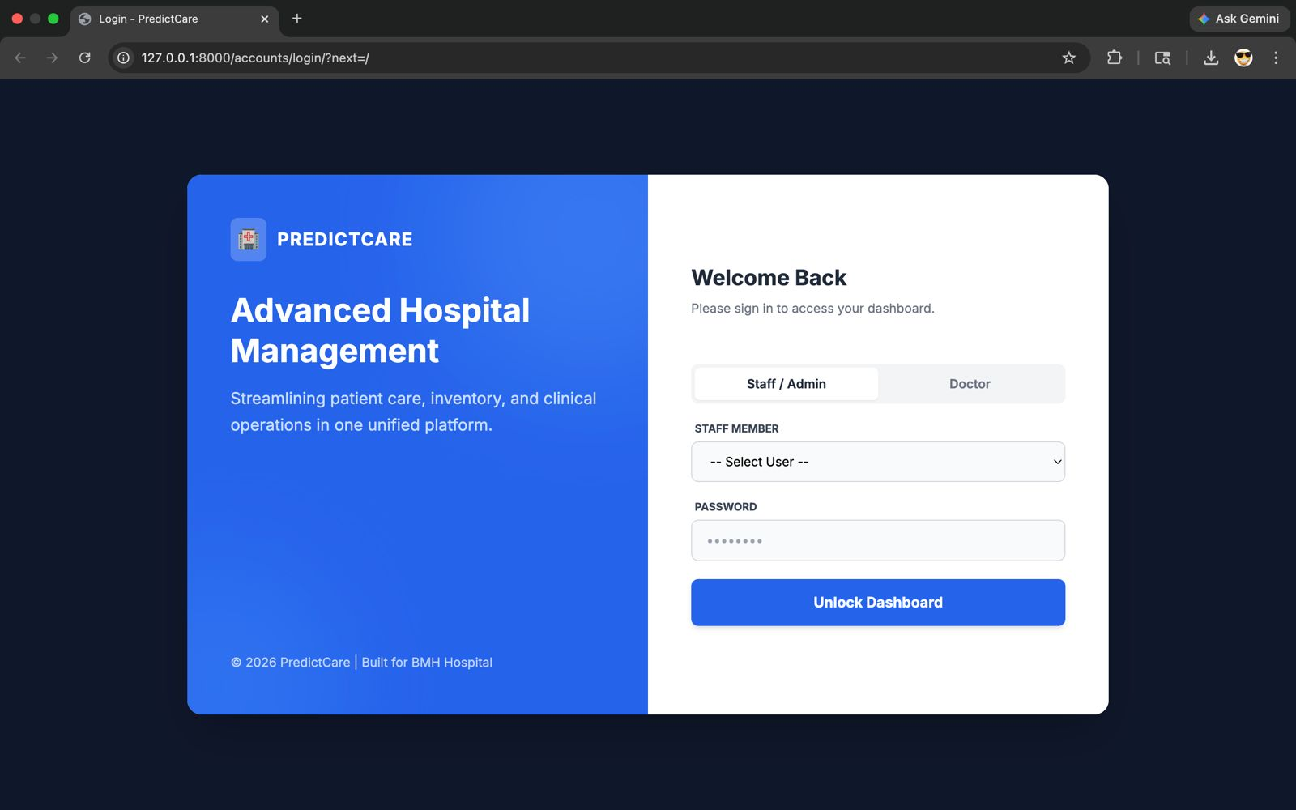

- Admin Dashboard

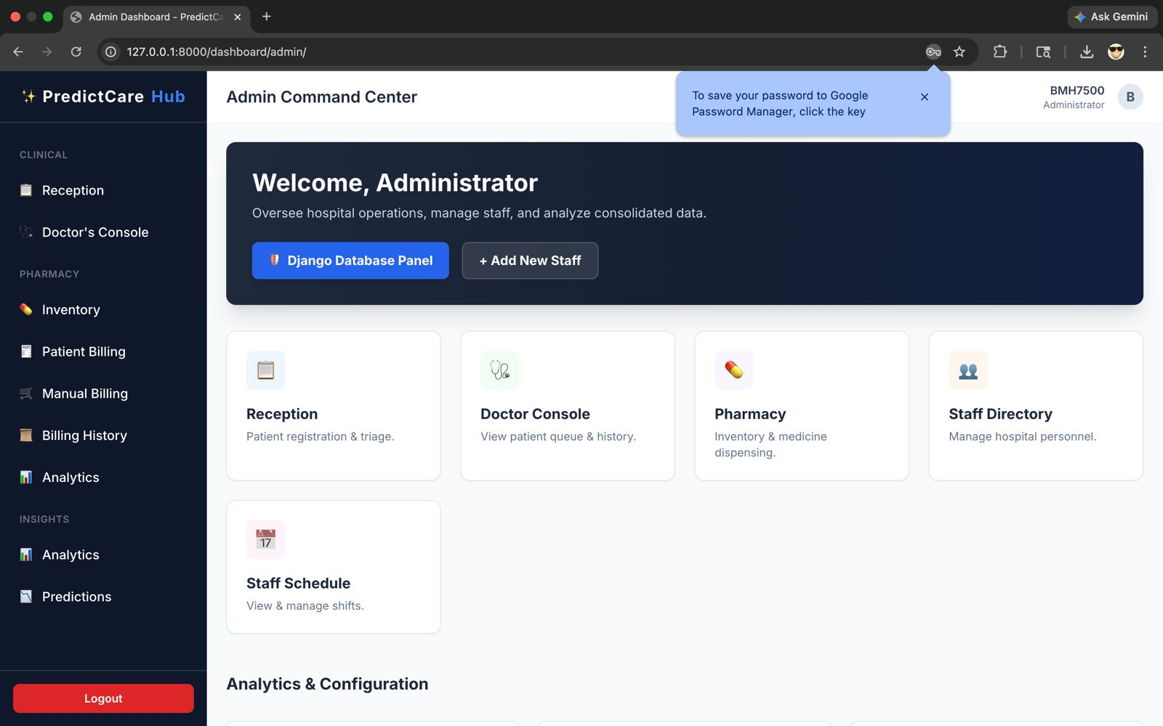

- Admin- Manage Staff

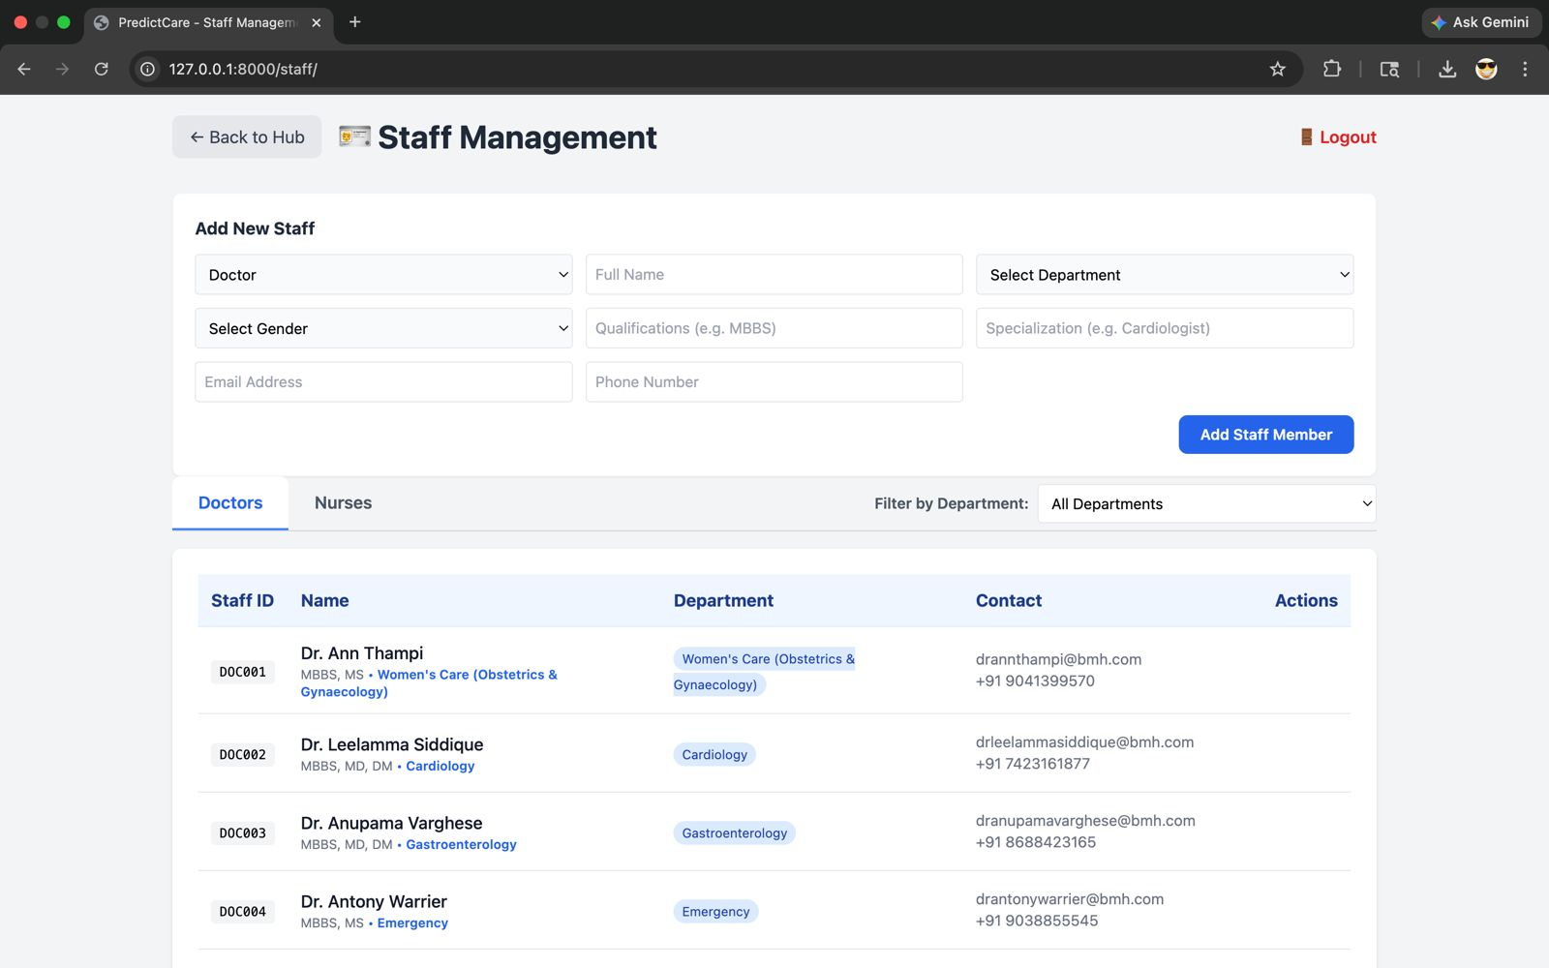

- Admin- Manage Staff Schedule
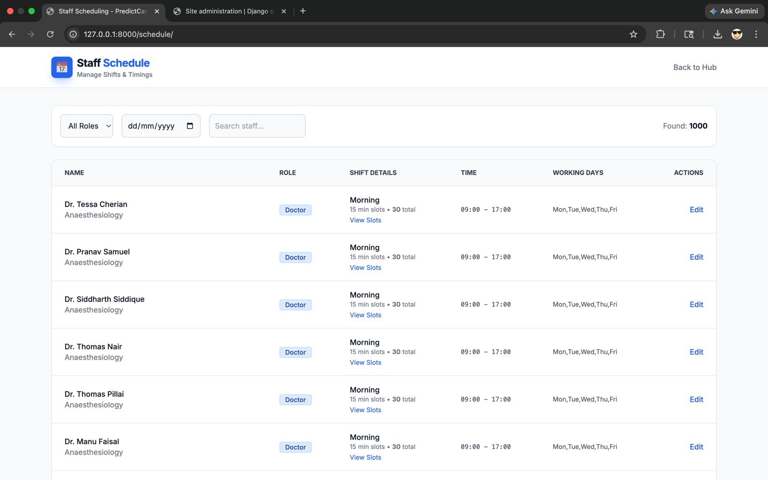

- Admin- View and Generate Reports
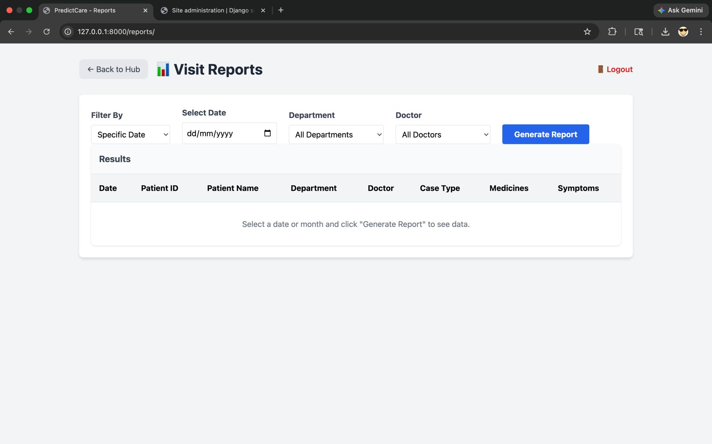

- Admin- Department Management
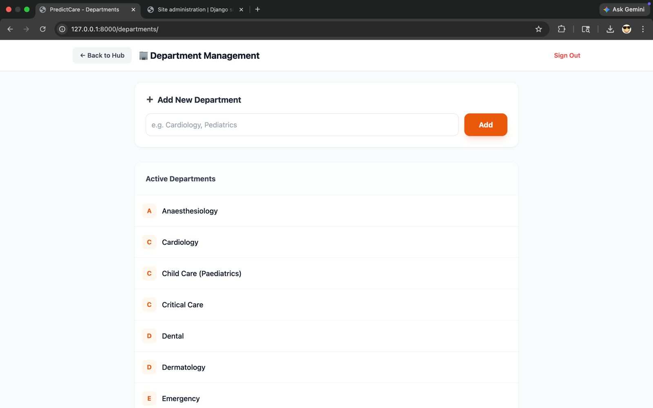

- Admin- View Predictions
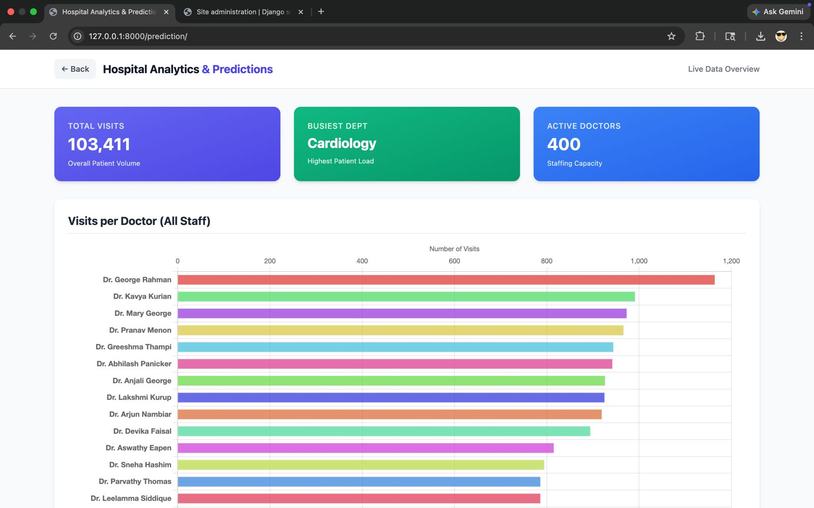

- Admin- View Analytics
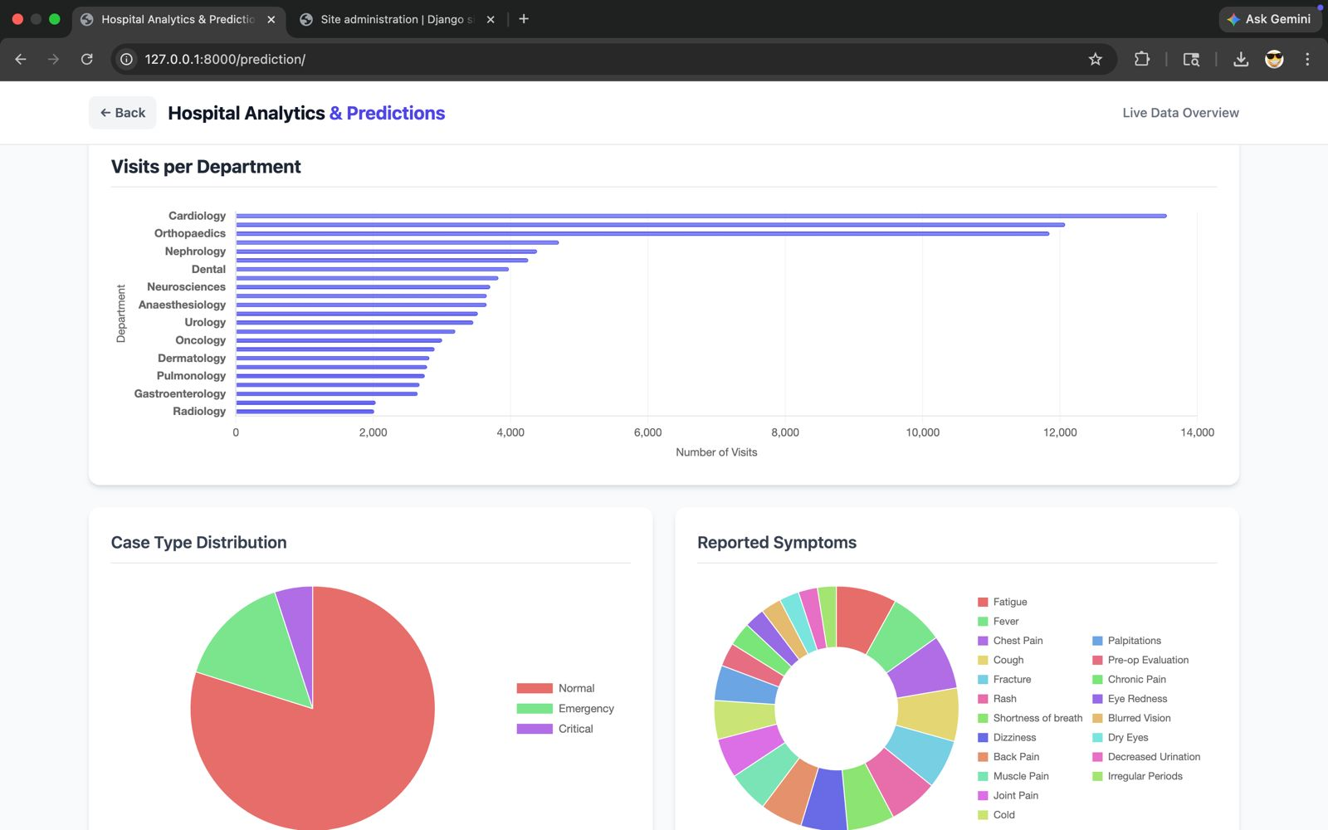

- Admin- View Analytics
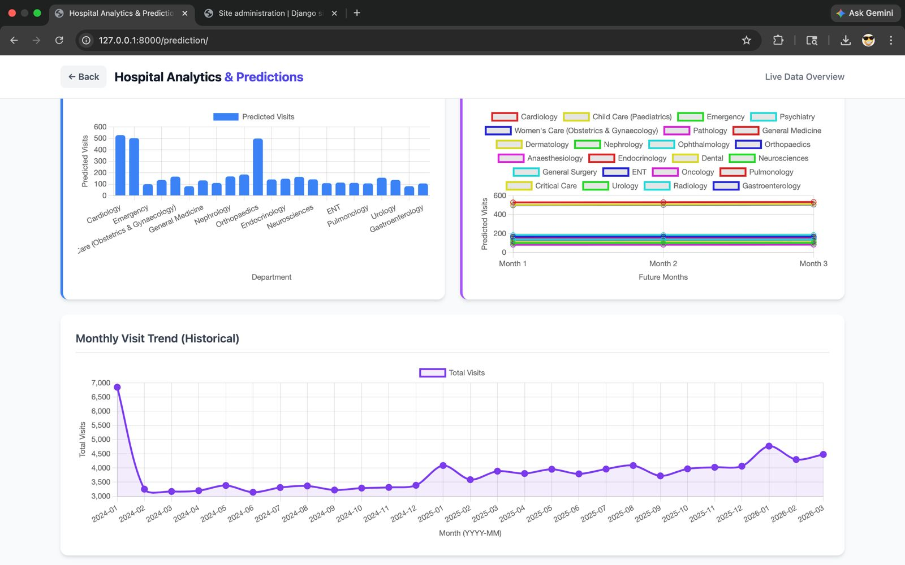

- Admin- View Resource Planning and AI
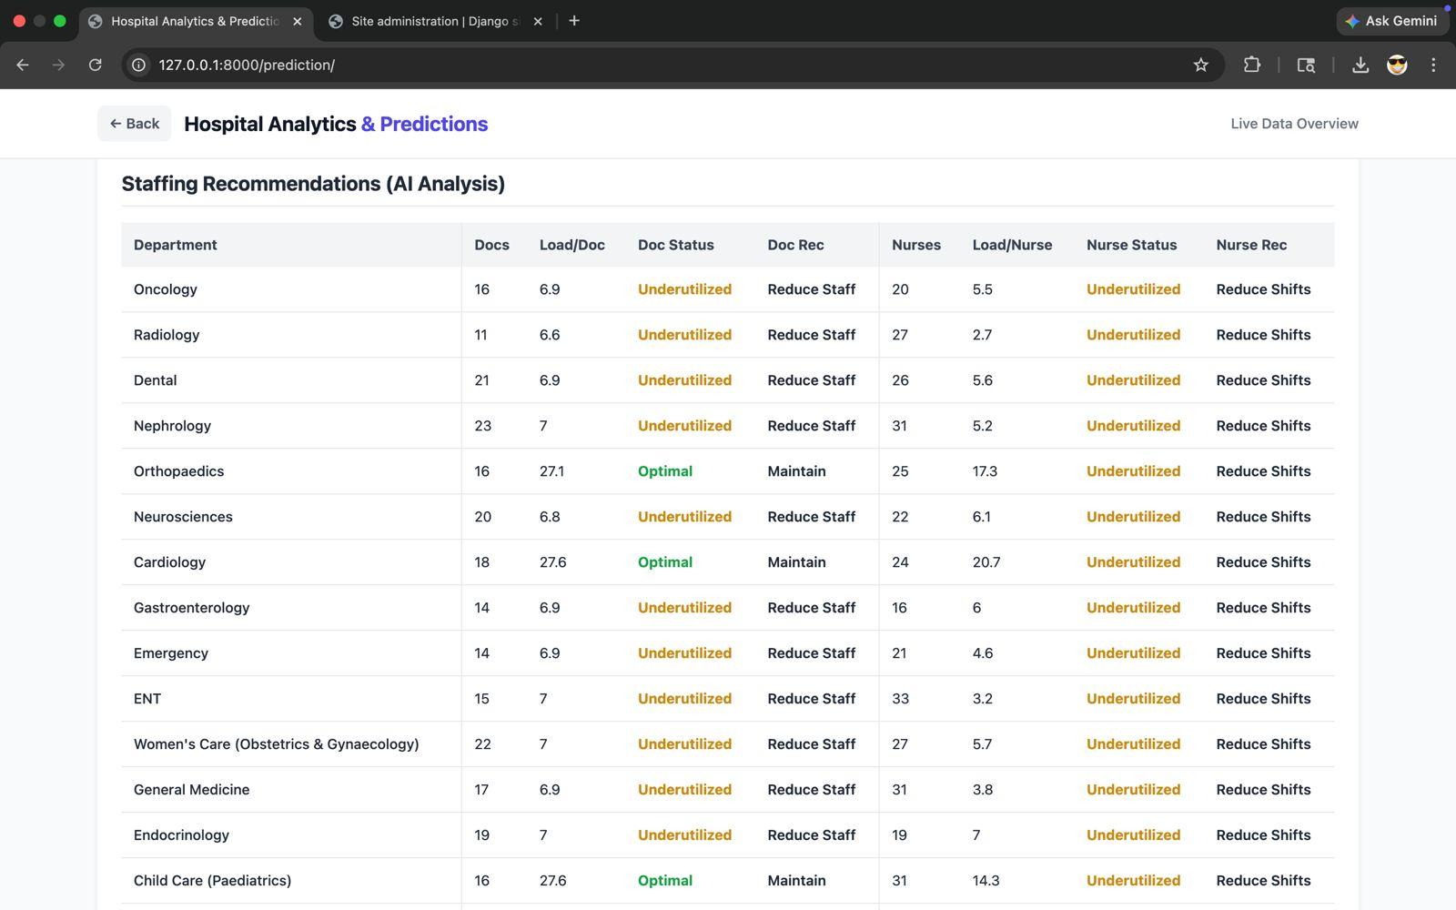

- Admin-Pharmacy Inventory
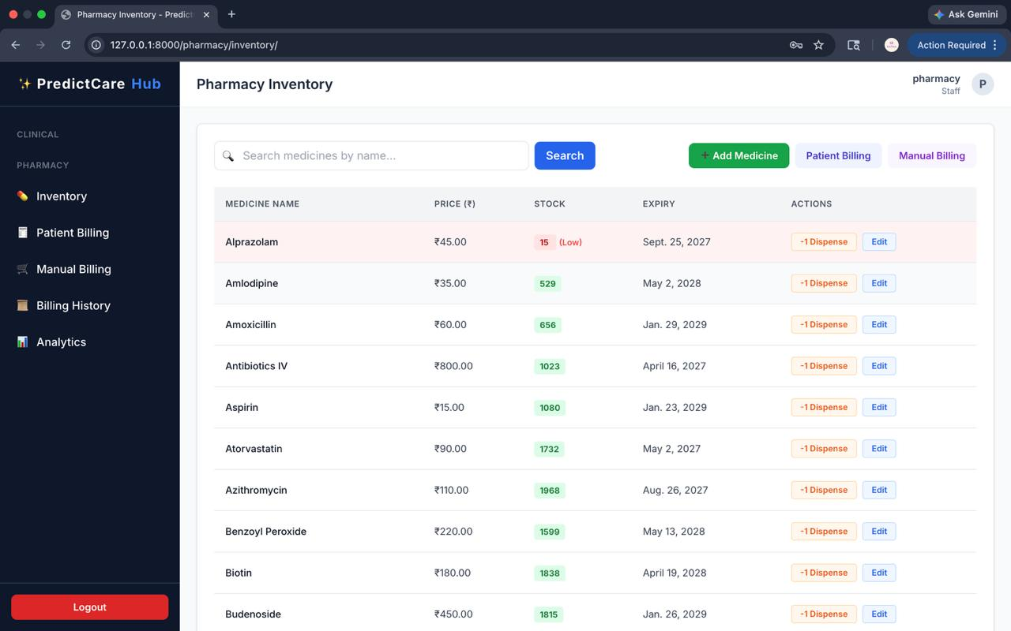

- Admin- Patient Billing
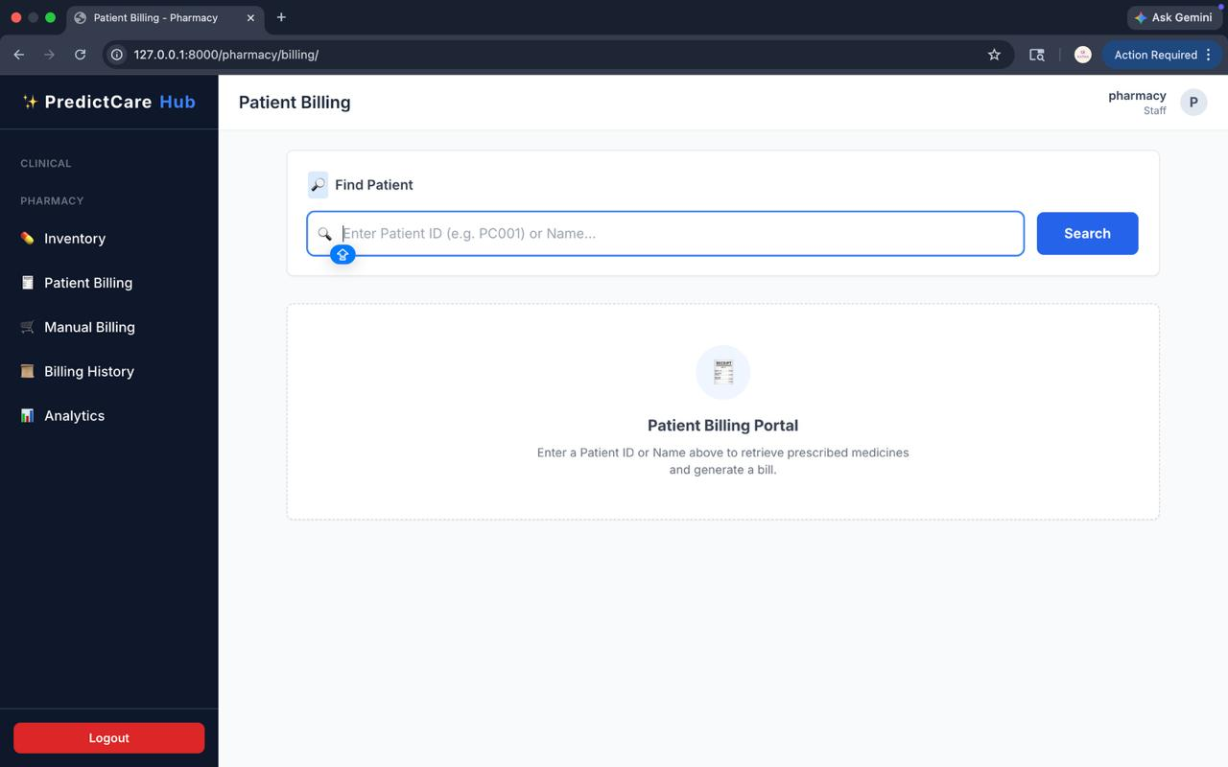

13.Admin- Manual Billing Counter
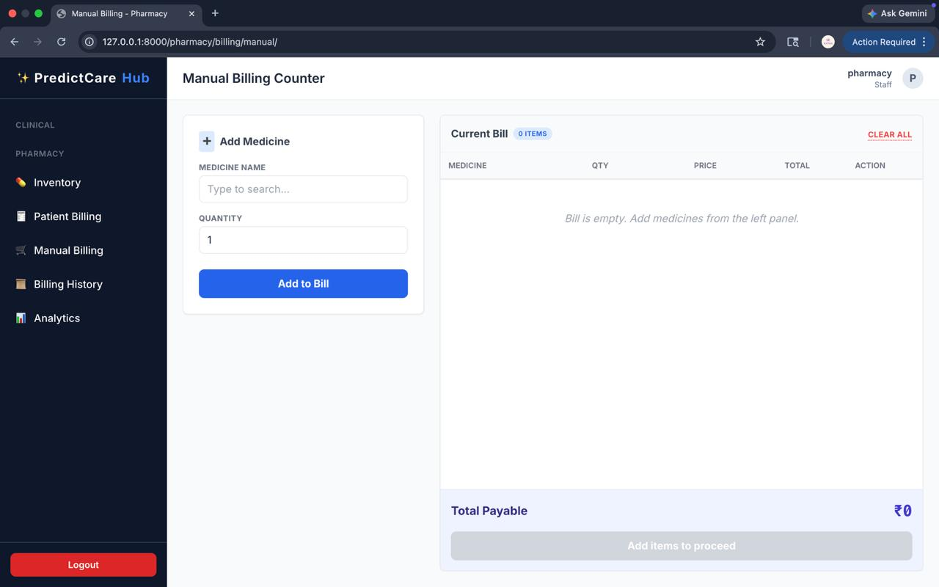

14.Admin- Pharmacy Insights & Forensics
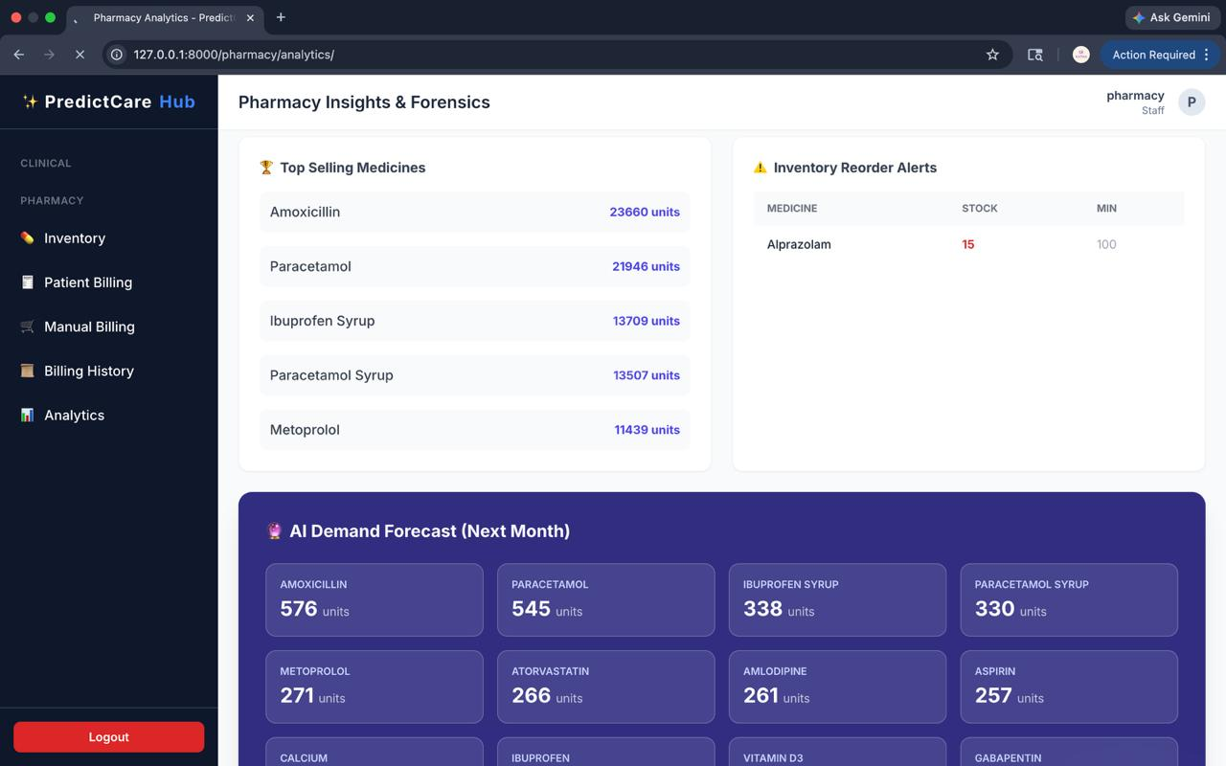

15. Admin-Reception Dashboard
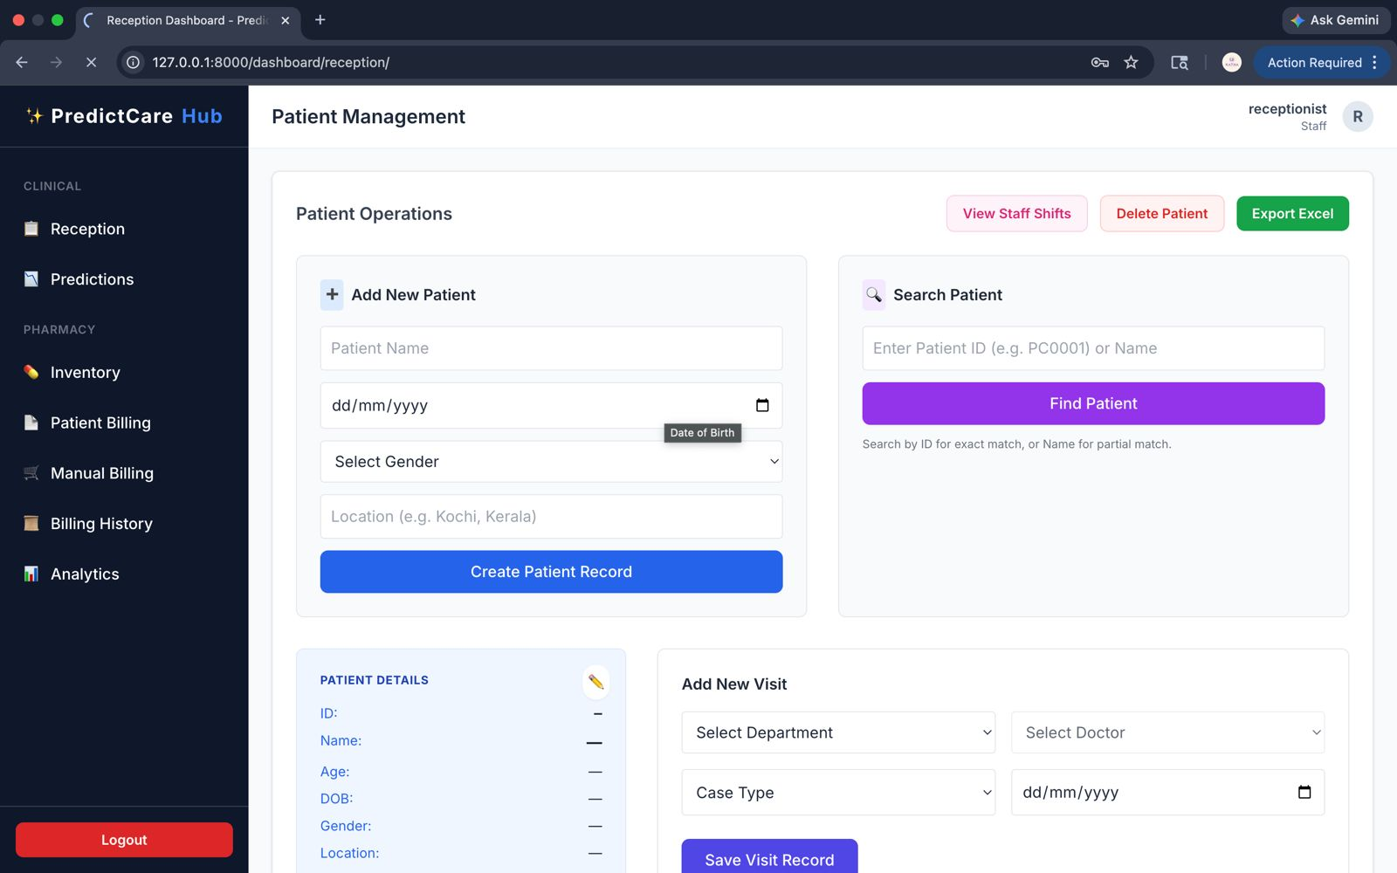

16.Admin- Reception Prediction & Insights
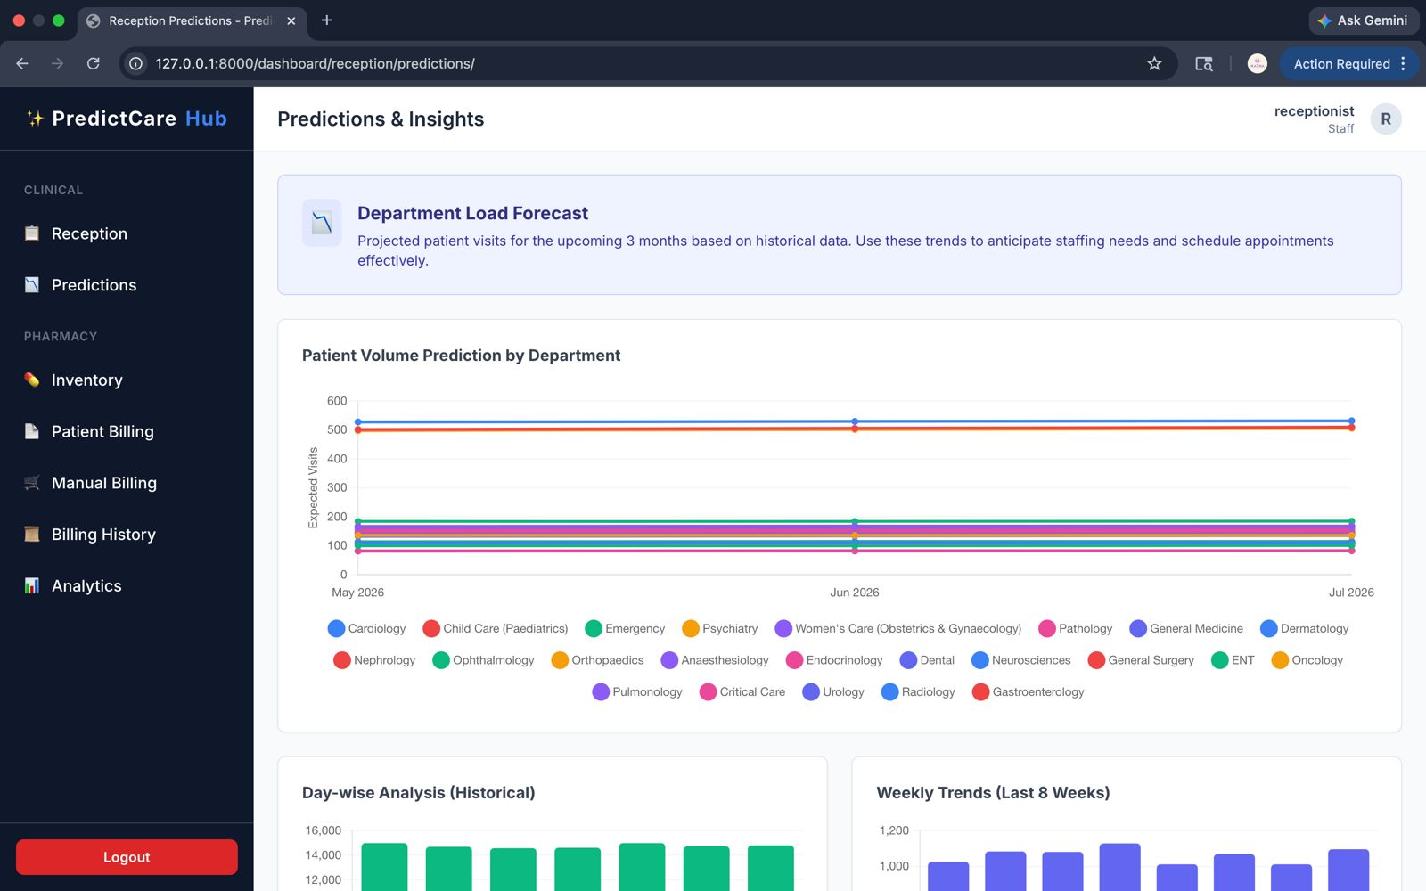

17.Admin- Reception Prediction & Insights
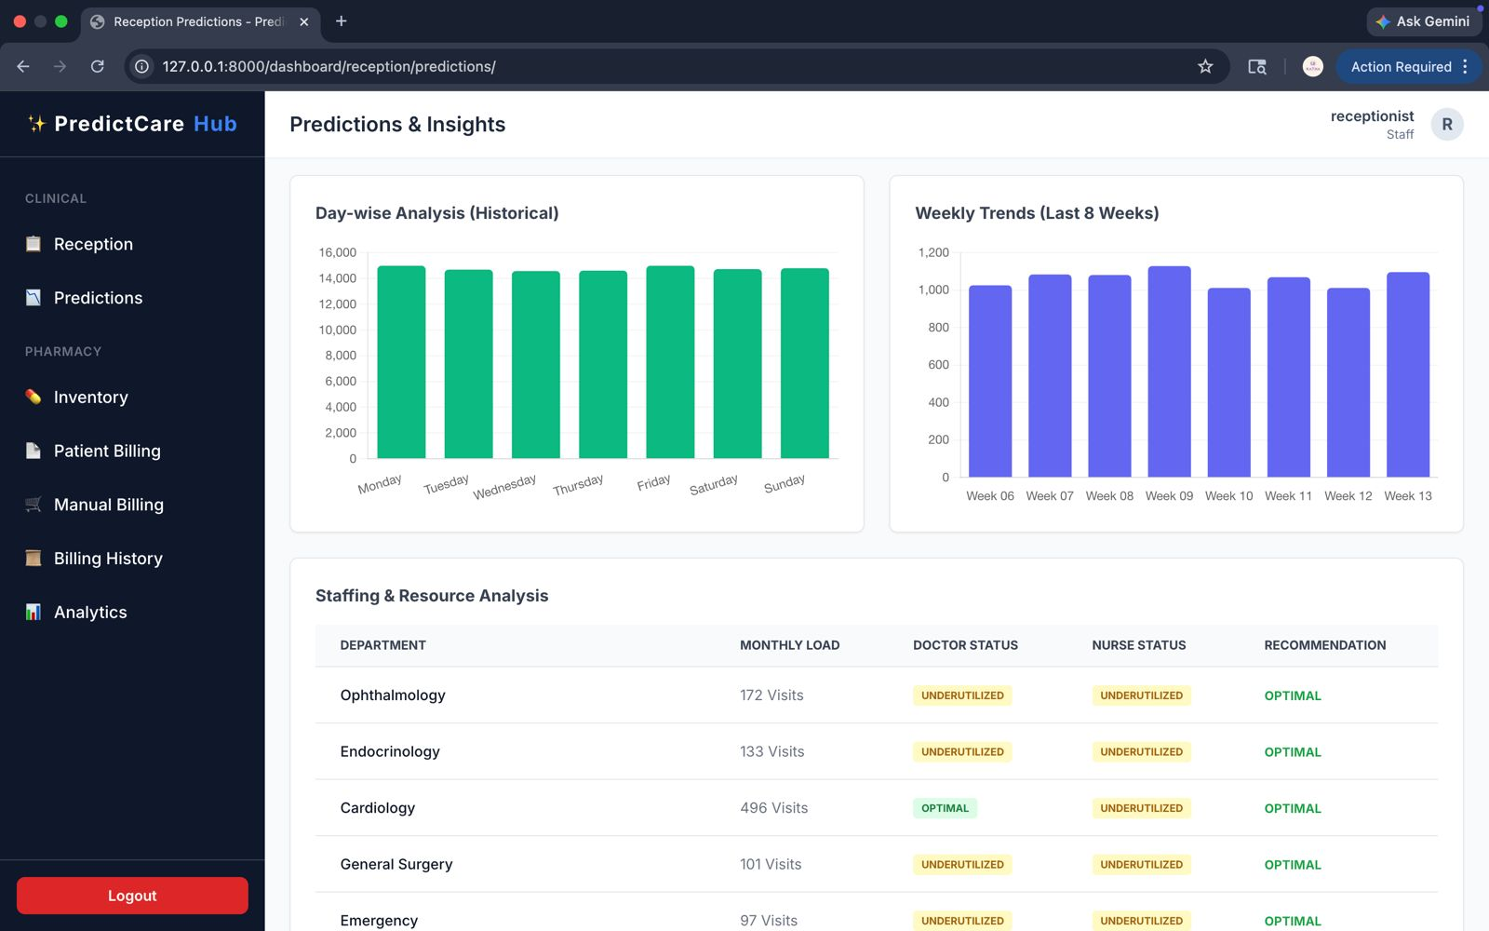

18. Doctor’s Console
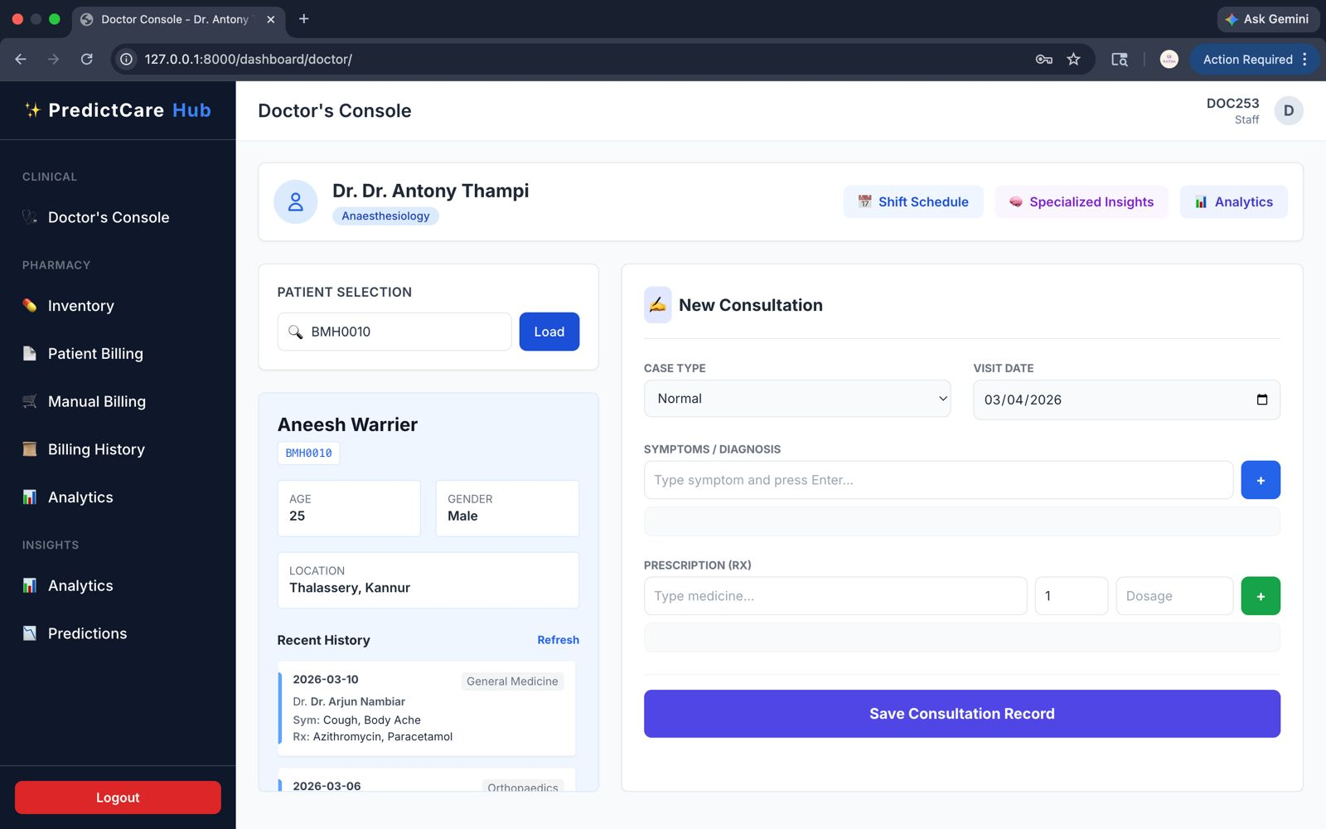

19. Doctor Analytics and Predictions
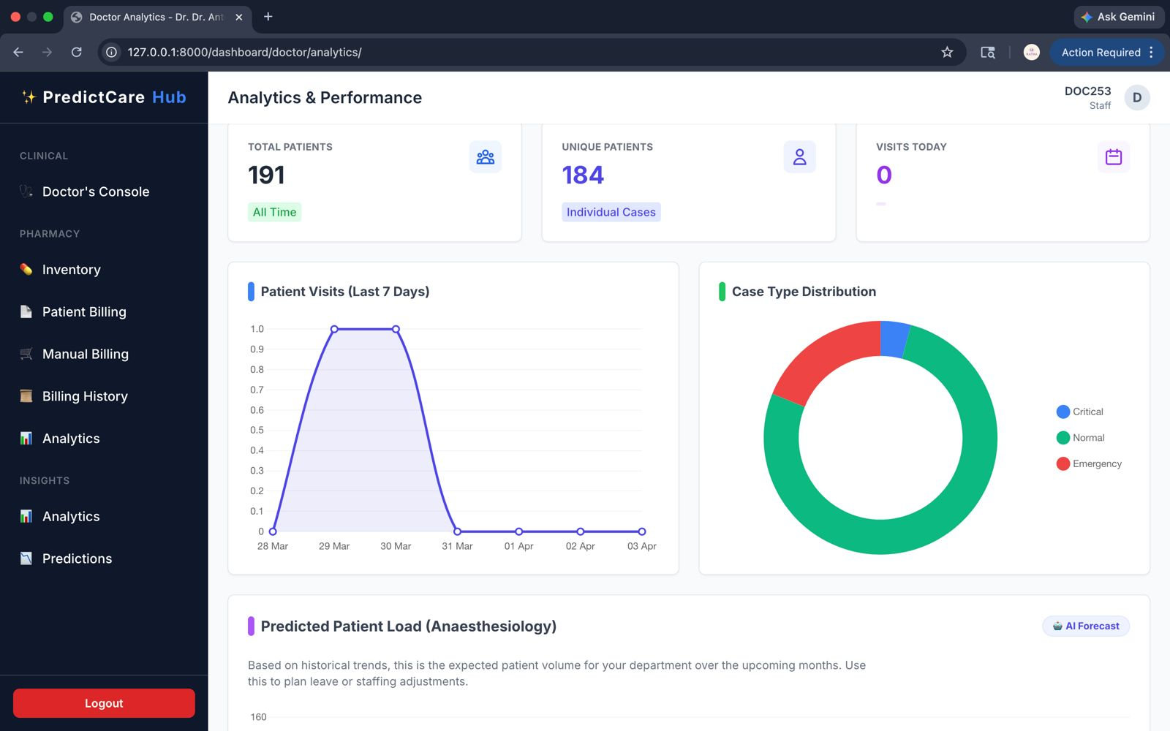

20. Pharmacy Billing History
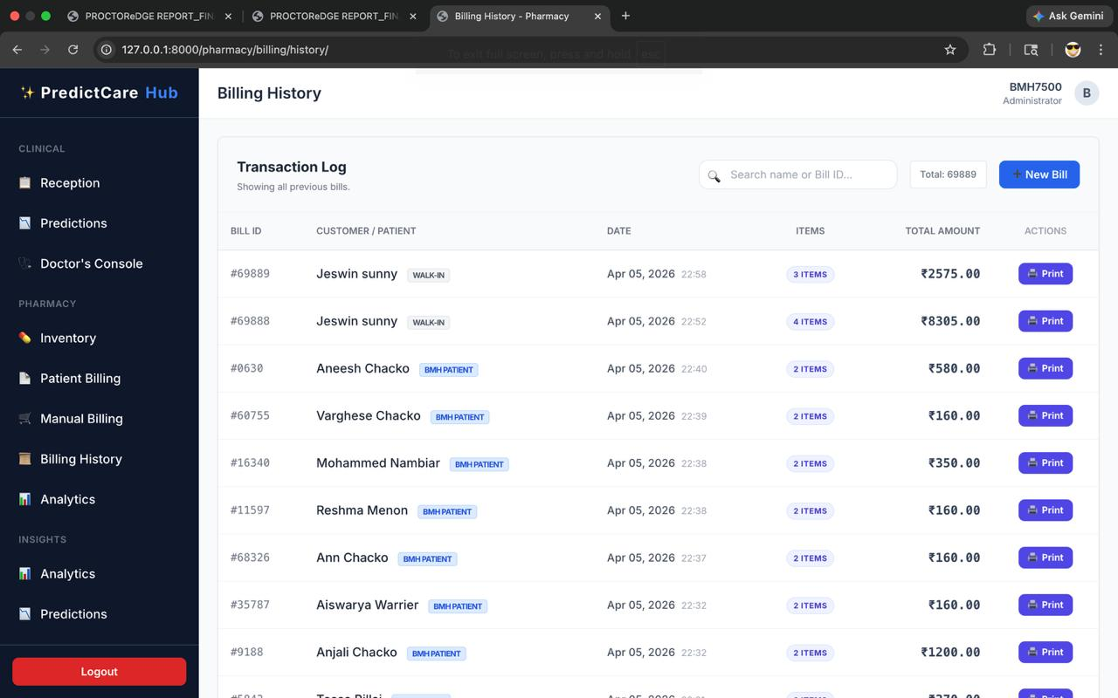

9. CONCLUSION

9.1 CONCLUSION
The PredictCare Hospital Management System represents a transformative milestone for Hospital, successfully migrating manual healthcare processes into a unified, AI-driven digital ecosystem. By bridging the gap between traditional clinical administration and modern data science, this project provides a scalable and robust platform designed for the future of healthcare.
Through the systematic implementation of its core modules, the project has achieved the following key objectives:
1. Operational Synchronization
The system has effectively unified patient registration, visit tracking, and staff management into a single "Source of Truth" backed by PostgreSQL. This ensures that every department—from the Receptionist logging a visit to the Doctor issuing a diagnosis—operates on real-time, consistent data, drastically reducing administrative delays and eliminating paper-based errors.
2. Algorithmic Staff Optimization
A standout innovation of this project is the SMSR (Staff Management & Shift Rotation) engine. By utilizing a mathematical modulo-based rotation model, PredictCare guarantees 24/7 hospital coverage without manual scheduling conflicts. This ensures that critical departments always have optimal staffing levels while maintaining fairness and transparency in shift allocations for doctors and nurses.
3. Integrated Pharmacy & Financial Control
The pharmacy module has evolved from a simple inventory tracker to an intelligent logistics hub. The seamless integration between doctor prescriptions and pharmacy billing ensures that medicine stock is deducted instantly upon dispensing. Automated low-stock alerts and integrated financial reporting provide the hospital with unprecedented control over its inventory and revenue cycles.
4. Data-Driven Predictive Intelligence
By leveraging Machine Learning (Scikit-Learn), PredictCare has transitioned the hospital from reactive to proactive management. The predictive dashboards for department load forecasting and medicine demand allow administrators to anticipate patient surges and stock requirements up to three months in advance, enabling smarter resource allocation and enhanced patient care.
Final Reflection
In conclusion, PredictCare is a production-ready solution that balances operational efficiency with cutting-edge technology. It demonstrates how modern web frameworks like Django can be combined with Data Science to solve complex real-world problems in the healthcare sector. The project stands as a complete, secure, and intelligent platform that is ready to serve the needs of patients and medical staff alike.

9.2 FUTURE SCOPE
While the current implementation of PredictCare provides a solid foundation for hospital operations, there is significant potential for expansion. The modular architecture of the system allows for the integration of emerging technologies to further enhance patient outcomes and operational efficiency.
The following areas represent the future roadmap for the system:

1. IoT-Enabled Patient Monitoring (Smart Healthcare)
Future versions will integrate with IoT (Internet of Things) devices such as smart beds, wearable heart-rate monitors, and automated BP machines. Real-time patient vitals will be streamed directly to the Doctor’s Dashboard, allowing for immediate alerts and "Zero-Delay" emergency responses.
2. Deep Learning for Medical Diagnostics
The current Linear Regression models can be expanded into Convolutional Neural Networks (CNNs). This will enable the system to perform automated medical image analysis, assisting radiologists in detecting anomalies in X-rays, MRIs, and CT scans with high accuracy, serving as a powerful decision-support tool for clinicians.
3. Telemedicine & Remote Consultation Hub
To extend the hospital's reach beyond physical boundaries, a Telemedicine Module will be integrated. This will include high-definition video conferencing, secure digital prescription sharing, and an integrated payment gateway, allowing patients in remote areas to consult with Specialists from their homes.
4. Blockchain-Backed Medical Records
To ensure the absolute privacy and integrity of sensitive patient data, Blockchain Technology will be explored for electronic health records (EHR). This will provide an un-hackable, decentralized ledger of medical history that can be securely shared with other healthcare providers only with the patient's explicit digital consent.
5. PredictCare Mobile Ecosystem
A dedicated Mobile Application for both iOS and Android will be developed.

For Patients: Appointment booking, digital health cards, and automated medication reminders.
For Staff: Real-time shift notifications, internal communication, and rapid document scanning using mobile cameras.
6. Pharmacy E-Commerce & Home Delivery
The pharmacy module will be transformed into a full-scale E-commerce platform. Patients will be able to order medicines directly through the portal, with the system verifying their digital prescriptions and tracking the delivery status in real-time.
7. Multihospital & Cloud Scalability
The system will be enhanced to support Multi-Hospital Chains. A centralized "Command Cen ter" will allow administrators to manage multiple branches, share specialists between locations, and analyse aggregated health trends across entire regions via a secure cloud infrastructure.

10.REFERENCES

10.0 REFERENCES
- Holovaty, A., Kaplan-Moss, J., “The Definitive Guide to Django: Web Development Done Right”, Apress, 2020.
- Obe, R. O., Hsu, L. S., “PostgreSQL: Up and Running: A Practical Guide to the Advanced Database”, O'Reilly Media, 2022.
- Pedregosa, F., et al., "Scikit-learn: Machine Learning in Python", Journal of Machine Learning Research, 2011.
- Raschka, S., Mirjalili, V., "Python Machine Learning: Machine Learning and Deep Learning with Python", Packt Publishing, 2019.
- Al-Janabi, S., et al., "Smart Hospital Management System using Artificial Intelligence and Machine Learning", Procedia Computer Science, 2023.
- Sharma, R., et al., “Predictive Analytics in Healthcare: Forecasting Patient Volumes and Resource Allocation”, IEEE International Conference on Healthcare Informatics (ICHI), 2024.
- Miah, S. J., et al., "An AI-based Approach for Automated Staff Scheduling in Healthcare Facilities", Journal of Medical Systems, 2023.
- Gupta, A., “A Mathematical Model for 24/7 Shift Rotation in Hospitals”, International Journal of Operations Research, 2022.
- McKinney, W., "Data Structures for Statistical Computing in Python (Pandas)", Proceedings of the Python in Science Conference, 2010.
- Django Project Documentation – https://docs.djangoproject.com
- PostgreSQL Official Documentation – https://www.postgresql.org/docs/
- Scikit-learn Documentation – https://scikit-learn.org/stable/
- Tailwind CSS Documentation – https://tailwindcss.com/docs

